A data warehouse is constructed by integrating data from multiple heterogeneous sources.

The term "Data Warehouse" was first coined by Bill Inmon in 1990. According to Inmon, a data warehouse is a subject oriented, integrated, time-variant, and non-volatile collection of data.

Data Warehouse Features

The key features of a data warehouse are discussed below −

**Subject Oriented** − A data warehouse is subject oriented because it provides information around a subject rather than the organization's ongoing operations. These subjects can be product, customers, suppliers, sales, revenue, etc

**Integrated** − A data warehouse is constructed by integrating data from heterogeneous sources such as relational databases, flat files, etc.

**Time Variant** − The data collected in a data warehouse is identified with a particular time period. The data in a data warehouse provides information from the historical point of view.

**Non-volatile** − Non-volatile means the previous data is not erased when new data is added to it.

**Data lakes** and **data warehouses** are both widely used for storing big **data**, but they are not interchangeable terms. A **data lake** is a vast pool of raw **data**, the purpose for which is not yet defined. A **data warehouse** is a repository for structured, filtered **data** that has already been processed for a specific purpose.

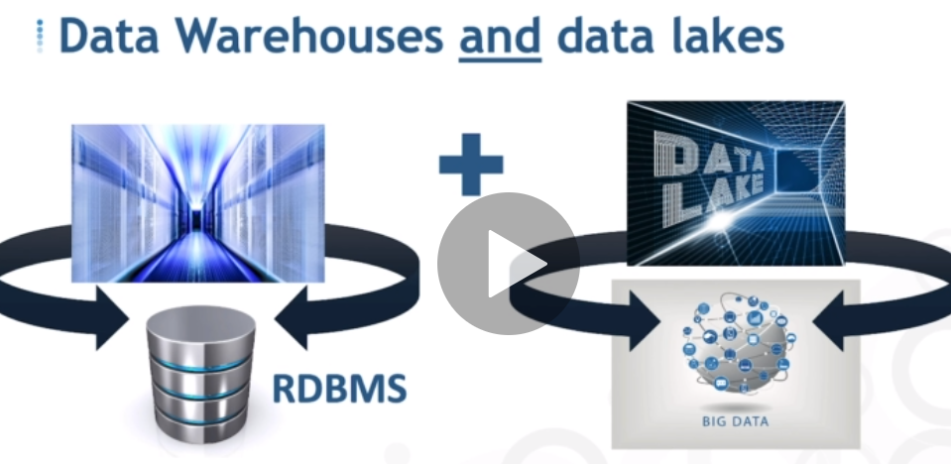

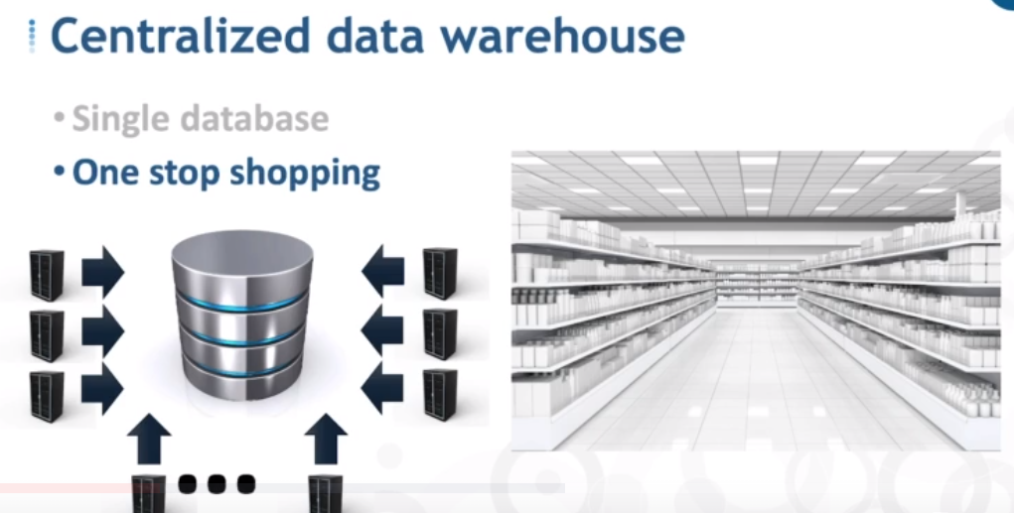

## What is a data warehouse?

A [**data warehouse**](https://www.stitchdata.com/resources/glossary/data-warehouse/) is a repository that stores all of an organization’s current and historical data from disparate sources — it’s sometimes called a single source of truth.

## What is a data mart?

A data mart is similar to a data warehouse, but it holds data only for a specific department or line of business, such as sales, finance, or human resources. A data warehouse can feed data to a data mart, or a data mart can feed a data warehouse.

## Data mart use cases

A data mart, on the other hand, contains data from a few sources with information specific to a business line or department. If a manufacturing manager wants to analyze production delays, she can go to her data mart, query the data, and run reports to determine where faults lie in the production line. She can extract and analyze it quickly because of the limited scope and size of the data.

|  |  |
| --- | --- |
| **Data warehouse** | **Data mart** |
| **Objective** | Centralize data, become single source of truth across business | Provide easy access to data for a department or specific line of business |
| **Uses** | Business-wide analysis | Department-specific analysis |
| **Decision types** | Strategic decision-making | Operational or tactical decision-making |
| **Scope** | Wide; contains data from all departments and lines of business | Specific; individual data marts for individual departments |
| **Size** | Typically more than 100GB | Less than 100GB |
| **Data held** | All organizational data | Single business line |
| **Data sources** | Dozens or hundreds | Typically just a few |
| **Time to implement** | Months to years (on-premises); days to weeks (cloud-based) | Weeks to months (on-premises); days to weeks (cloud-based) |
| **Cost** | $100K+ (on-premises); on-demand pricing varies (SaaS) | $10K (on-premises); on-demand pricing varies (SaaS) |

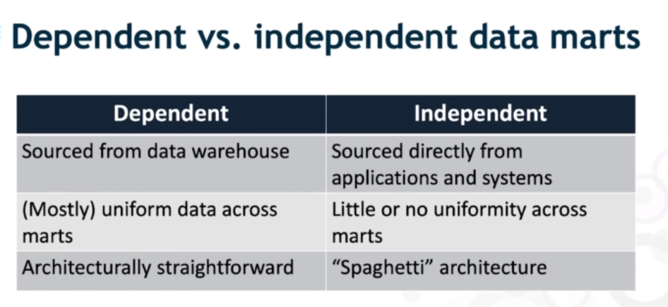

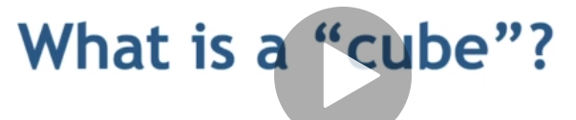

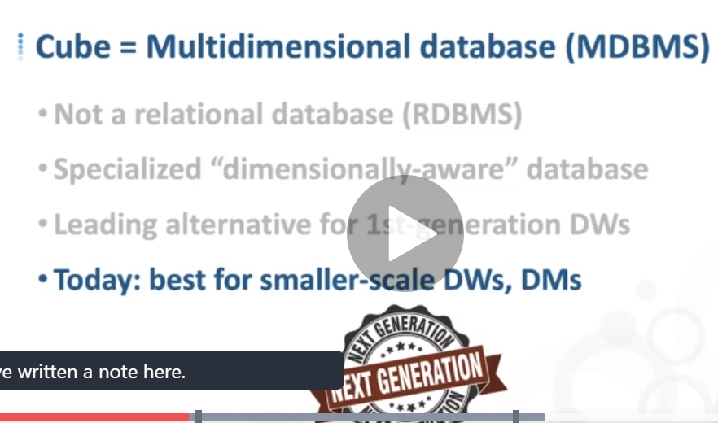

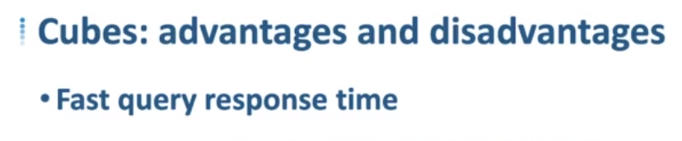

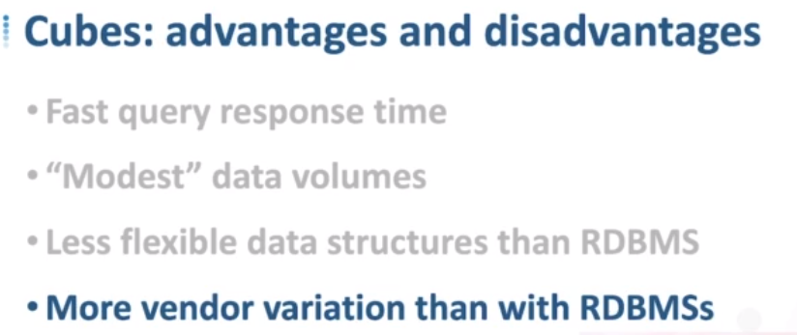

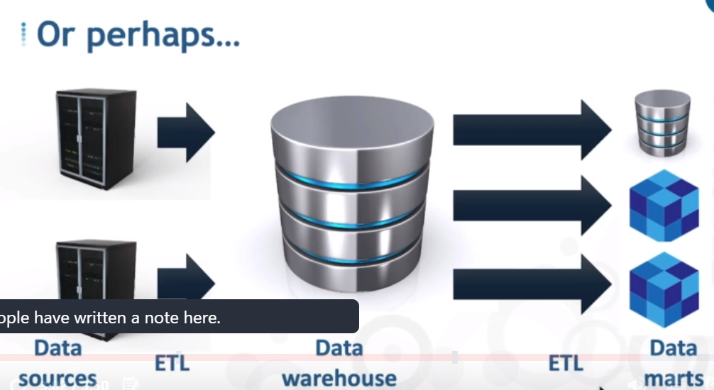

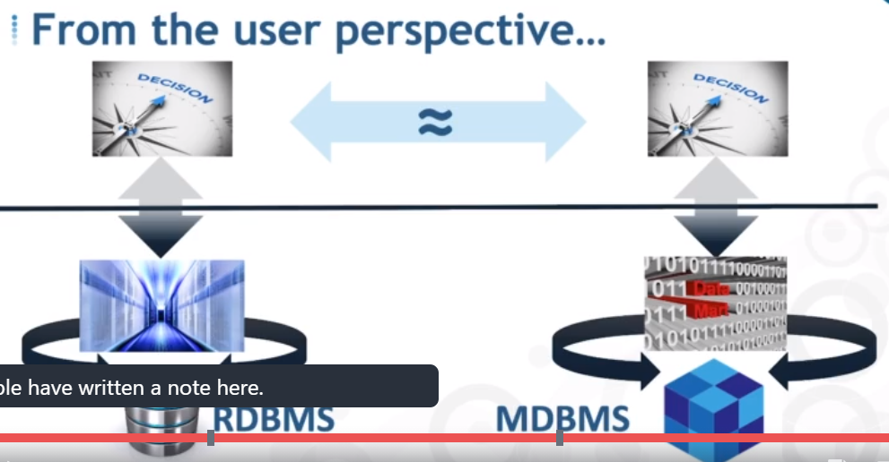

## Data Cube

A data cube helps us represent data in multiple dimensions. It is defined by dimensions and facts. The dimensions are the entities with respect to which an enterprise preserves the records.

### **Illustration of Data Cube**

Suppose a company wants to keep track of sales records with the help of sales data warehouse with respect to time, item, branch, and location. These dimensions allow to keep track of monthly sales and at which branch the items were sold. There is a table associated with each dimension. This table is known as dimension table. For example, "item" dimension table may have attributes such as item_name, item_type, and item_brand.

The following table represents the 2-D view of Sales Data for a company with respect to time, item, and location dimensions.

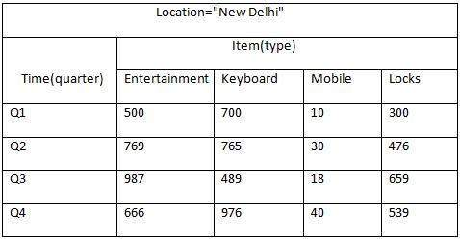

But here in this 2-D table, we have records with respect to time and item only. The sales for New Delhi are shown with respect to time, and item dimensions according to type of items sold. If we want to view the sales data with one more dimension, say, the location dimension, then the 3-D view would be useful. The 3-D view of the sales data with respect to time, item, and location is shown in the table below −

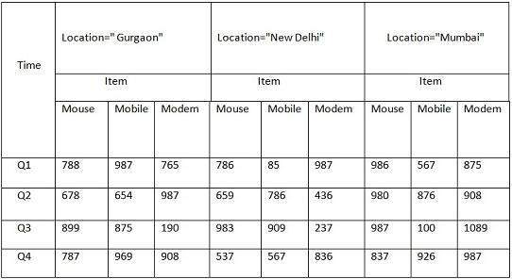

The above 3-D table can be represented as 3-D data cube as shown in the following figure −

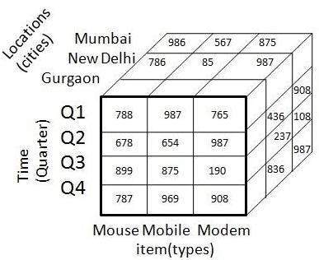

Online Analytical Processing Server (OLAP) is based on the multidimensional data model. It allows managers, and analysts to get an insight of the information through fast, consistent, and interactive access to information. This chapter cover the types of OLAP, operations on OLAP, difference between OLAP, and statistical databases and OLTP.

## Types of OLAP Servers

We have four types of OLAP servers −

* Relational OLAP (ROLAP)
* Multidimensional OLAP (MOLAP)
* Hybrid OLAP (HOLAP)
* Specialized SQL Servers

## Relational OLAP

ROLAP servers are placed between relational back-end server and client front-end tools. To store and manage warehouse data, ROLAP uses relational or extended-relational DBMS.

ROLAP includes the following −

* Implementation of aggregation navigation logic.
* Optimization for each DBMS back end.
* Additional tools and services.

## Multidimensional OLAP

MOLAP uses array-based multidimensional storage engines for multidimensional views of data. With multidimensional data stores, the storage utilization may be low if the data set is sparse. Therefore, many MOLAP server use two levels of data storage representation to handle dense and sparse data sets.

## Hybrid OLAP

Hybrid OLAP is a combination of both ROLAP and MOLAP. It offers higher scalability of ROLAP and faster computation of MOLAP. HOLAP servers allows to store the large data volumes of detailed information. The aggregations are stored separately in MOLAP store.

## Specialized SQL Servers

Specialized SQL servers provide advanced query language and query processing support for SQL queries over star and snowflake schemas in a read-only environment.

## OLAP Operations

Since OLAP servers are based on multidimensional view of data, we will discuss OLAP operations in multidimensional data.

Here is the list of OLAP operations −

* Roll-up
* Drill-down
* Slice and dice
* Pivot (rotate)

### **Roll-up**

Roll-up performs aggregation on a data cube in any of the following ways −

* By climbing up a concept hierarchy for a dimension
* By dimension reduction

The following diagram illustrates how roll-up works.

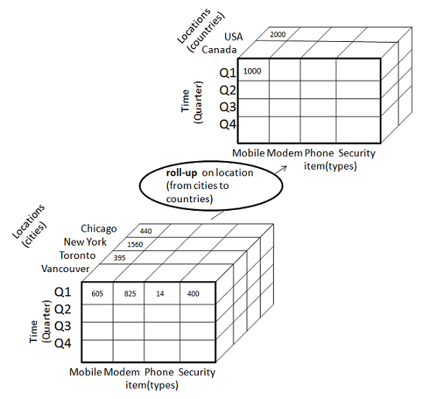

* Roll-up is performed by climbing up a concept hierarchy for the dimension location.
* Initially the concept hierarchy was "street < city < province < country".
* On rolling up, the data is aggregated by ascending the location hierarchy from the level of city to the level of country.
* The data is grouped into cities rather than countries.
* When roll-up is performed, one or more dimensions from the data cube are removed.

### **Drill-down**

Drill-down is the reverse operation of roll-up. It is performed by either of the following ways −

* By stepping down a concept hierarchy for a dimension
* By introducing a new dimension.

The following diagram illustrates how drill-down works −

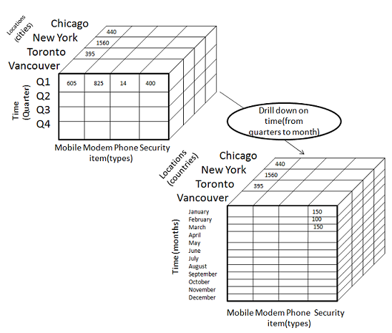

* Drill-down is performed by stepping down a concept hierarchy for the dimension time.
* Initially the concept hierarchy was "day < month < quarter < year."
* On drilling down, the time dimension is descended from the level of quarter to the level of month.
* When drill-down is performed, one or more dimensions from the data cube are added.
* It navigates the data from less detailed data to highly detailed data.

### **Slice**

The slice operation selects one particular dimension from a given cube and provides a new sub-cube. Consider the following diagram that shows how slice works.

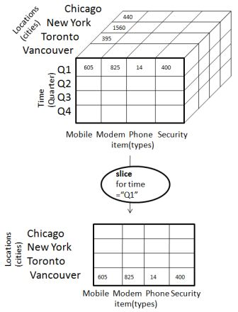

* Here Slice is performed for the dimension "time" using the criterion time = "Q1".
* It will form a new sub-cube by selecting one or more dimensions.

### **Dice**

Dice selects two or more dimensions from a given cube and provides a new sub-cube. Consider the following diagram that shows the dice operation.

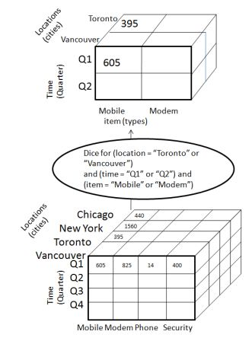

The dice operation on the cube based on the following selection criteria involves three dimensions.

* (location = "Toronto" or "Vancouver")
* (time = "Q1" or "Q2")
* (item =" Mobile" or "Modem")

### **Pivot**

The pivot operation is also known as rotation. It rotates the data axes in view in order to provide an alternative presentation of data. Consider the following diagram that shows the pivot operation.

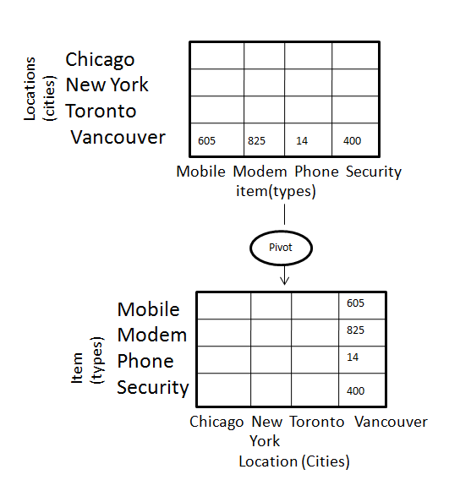

Partitioning is done to enhance performance and facilitate easy management of data. Partitioning also helps in balancing the various requirements of the system. It optimizes the hardware performance and simplifies the management of data warehouse by partitioning each fact table into multiple separate partitions. In this chapter, we will discuss different partitioning strategies.

## Why is it Necessary to Partition?

Partitioning is important for the following reasons −

* For easy management,
* To assist backup/recovery,
* To enhance performance.

### **For Easy Management**

The fact table in a data warehouse can grow up to hundreds of gigabytes in size. This huge size of fact table is very hard to manage as a single entity. Therefore it needs partitioning.

### **To Assist Backup/Recovery**

If we do not partition the fact table, then we have to load the complete fact table with all the data. Partitioning allows us to load only as much data as is required on a regular basis. It reduces the time to load and also enhances the performance of the system.

**Note** − To cut down on the backup size, all partitions other than the current partition can be marked as read-only. We can then put these partitions into a state where they cannot be modified. Then they can be backed up. It means only the current partition is to be backed up.

### **To Enhance Performance**

By partitioning the fact table into sets of data, the query procedures can be enhanced. Query performance is enhanced because now the query scans only those partitions that are relevant. It does not have to scan the whole data.

## Horizontal Partitioning

There are various ways in which a fact table can be partitioned. In horizontal partitioning, we have to keep in mind the requirements for manageability of the data warehouse.

### **Partitioning by Time into Equal Segments**

In this partitioning strategy, the fact table is partitioned on the basis of time period. Here each time period represents a significant retention period within the business. For example, if the user queries for **month to date data** then it is appropriate to partition the data into monthly segments. We can reuse the partitioned tables by removing the data in them.

### **Partition by Time into Different-sized Segments**

This kind of partition is done where the aged data is accessed infrequently. It is implemented as a set of small partitions for relatively current data, larger partition for inactive data.

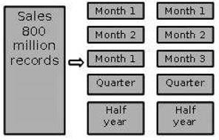

### **Points to Note**

* The detailed information remains available online.
* The number of physical tables is kept relatively small, which reduces the operating cost.
* This technique is suitable where a mix of data dipping recent history and data mining through entire history is required.
* This technique is not useful where the partitioning profile changes on a regular basis, because repartitioning will increase the operation cost of data warehouse.

### **Partition on a Different Dimension**

The fact table can also be partitioned on the basis of dimensions other than time such as product group, region, supplier, or any other dimension. Let's have an example.

Suppose a market function has been structured into distinct regional departments like on a **state by state** basis. If each region wants to query on information captured within its region, it would prove to be more effective to partition the fact table into regional partitions. This will cause the queries to speed up because it does not require to scan information that is not relevant.

### **Points to Note**

* The query does not have to scan irrelevant data which speeds up the query process.
* This technique is not appropriate where the dimensions are unlikely to change in future. So, it is worth determining that the dimension does not change in future.
* If the dimension changes, then the entire fact table would have to be repartitioned.

**Note** − We recommend to perform the partition only on the basis of time dimension, unless you are certain that the suggested dimension grouping will not change within the life of the data warehouse.

### **Partition by Size of Table**

When there are no clear basis for partitioning the fact table on any dimension, then we should **partition the fact table on the basis of their size.** We can set the predetermined size as a critical point. When the table exceeds the predetermined size, a new table partition is created.

### **Points to Note**

* This partitioning is complex to manage.
* It requires metadata to identify what data is stored in each partition.

### **Partitioning Dimensions**

If a dimension contains large number of entries, then it is required to partition the dimensions. Here we have to check the size of a dimension.

Consider a large design that changes over time. If we need to store all the variations in order to apply comparisons, that dimension may be very large. This would definitely affect the response time.

### **Round Robin Partitions**

In the round robin technique, when a new partition is needed, the old one is archived. It uses metadata to allow user access tool to refer to the correct table partition.

This technique makes it easy to automate table management facilities within the data warehouse.

## Vertical Partition

Vertical partitioning, splits the data vertically. The following images depicts how vertical partitioning is done.

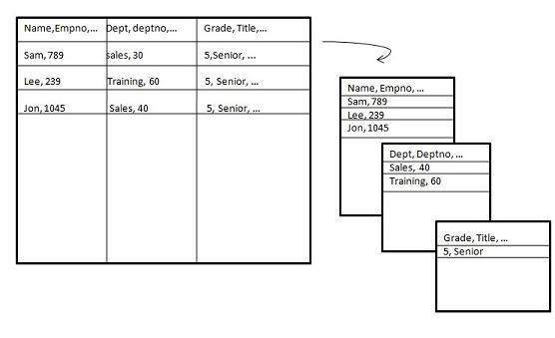

Vertical partitioning can be performed in the following two ways −

* Normalization
* Row Splitting

### **Normalization**

Normalization is the standard relational method of database organization. In this method, the rows are collapsed into a single row, hence it reduce space. Take a look at the following tables that show how normalization is performed.

Table before Normalization

|  |  |  |  |  |  |  |  |
| --- | --- | --- | --- | --- | --- | --- | --- |
| **Product_id** | **Qty** | **Value** | **sales_date** | **Store_id** | **Store_name** | **Location** | **Region** |
| 30 | 5 | 3.67 | 3-Aug-13 | 16 | sunny | Bangalore | S |
| 35 | 4 | 5.33 | 3-Sep-13 | 16 | sunny | Bangalore | S |
| 40 | 5 | 2.50 | 3-Sep-13 | 64 | san | Mumbai | W |
| 45 | 7 | 5.66 | 3-Sep-13 | 16 | sunny | Bangalore | S |

Table after Normalization

|  |  |  |  |
| --- | --- | --- | --- |
| **Store_id** | **Store_name** | **Location** | **Region** |
| 16 | sunny | Bangalore | W |
| 64 | san | Mumbai | S |

|  |  |  |  |  |
| --- | --- | --- | --- | --- |
| **Product_id** | **Quantity** | **Value** | **sales_date** | **Store_id** |
| 30 | 5 | 3.67 | 3-Aug-13 | 16 |
| 35 | 4 | 5.33 | 3-Sep-13 | 16 |
| 40 | 5 | 2.50 | 3-Sep-13 | 64 |
| 45 | 7 | 5.66 | 3-Sep-13 | 16 |

### **Row Splitting**

Row splitting tends to leave a one-to-one map between partitions. The motive of row splitting is to speed up the access to large table by reducing its size.

**Note** − While using vertical partitioning, make sure that there is no requirement to perform a major join operation between two partitions.

## Identify Key to Partition

It is very crucial to choose the right partition key. Choosing a wrong partition key will lead to reorganizing the fact table. Let's have an example. Suppose we want to partition the following table.

**Account_Txn_Table**

transaction_id

account_id

transaction_type

value

transaction_date

region

branch_name

We can choose to partition on any key. The two possible keys could be

* region
* transaction_date

Suppose the business is organized in 30 geographical regions and each region has different number of branches. That will give us 30 partitions, which is reasonable. This partitioning is good enough because our requirements capture has shown that a vast majority of queries are restricted to the user's own business region.

If we partition by transaction_date instead of region, then the latest transaction from every region will be in one partition. Now the user who wants to look at data within his own region has to query across multiple partitions.

Hence it is worth determining the right partitioning key.

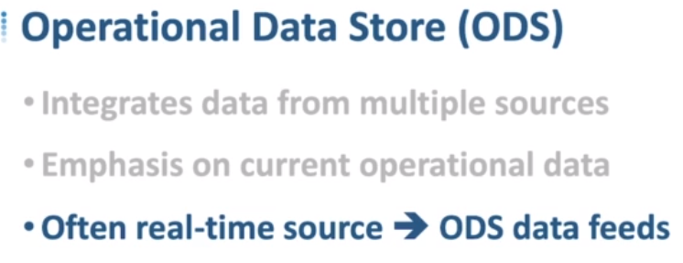

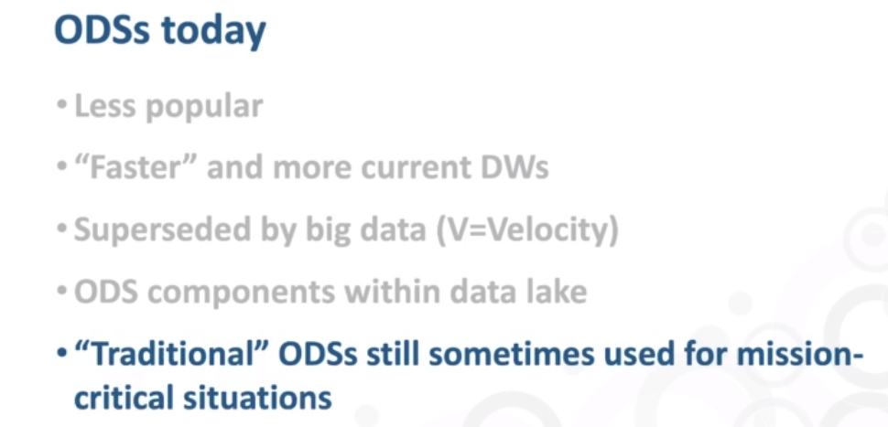

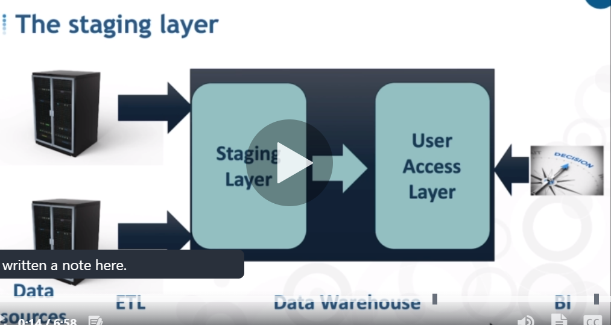

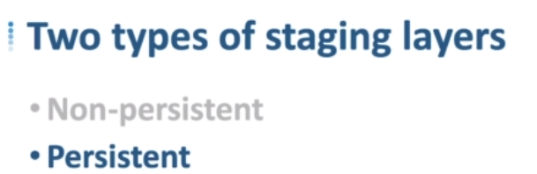

Non Persistent:- data will be deleted after the new data comes in

Persistent:- data will be there permanently even if new data comes in.

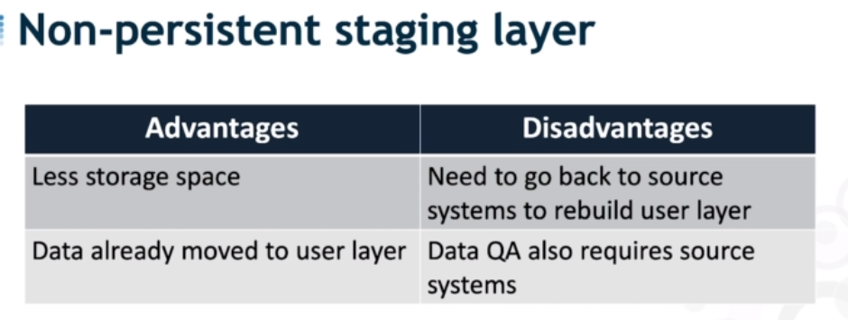

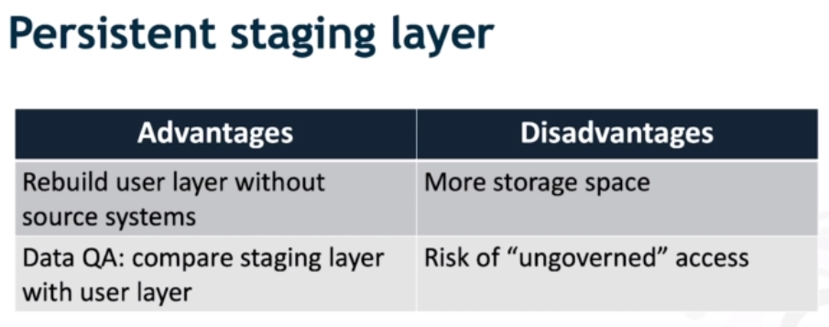

## What is ETL?

ETL is an abbreviation of Extract, Transform and Load. In this process, an ETL tool extracts the data from different RDBMS source systems then transforms the data like applying calculations, concatenations, etc. and then load the data into the Data Warehouse system.

[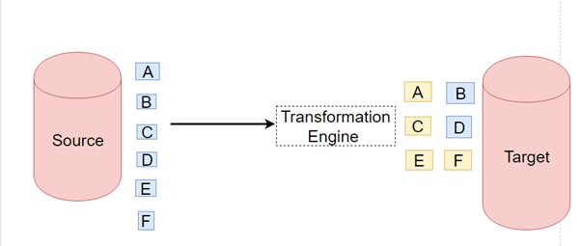](https://www.guru99.com/images/1/022218_0954_ETLvsELTMus1.png)

## What is ELT?

ELT is a different method of looking at the tool approach to data movement. Instead of transforming the data before it's written, ELT lets the target system to do the transformation. The data first copied to the target and then transformed in place.

ELT usually used with no-Sql databases like Hadoop cluster, data appliance or cloud installation.

[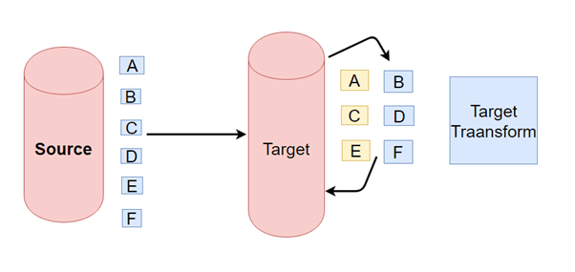](https://www.guru99.com/images/1/022218_0954_ETLvsELTMus2.png)

**KEY DIFFERENCE**

* ETL stands for Extract, Transform and Load while ELT stands for Extract, Load, Transform.
* ETL loads data first into the staging server and then into the target system whereas ELT loads data directly into the target system.
* ETL model is used for on-premises, relational and structured data while ELT is used for scalable cloud structured and unstructured data sources.
* ETL is mainly used for a small amount of data whereas ELT is used for large amounts of data.
* ETL doesn’t provide data lake supports while ELT provides data lake support.
* ETL is easy to implement whereas ELT requires niche skills to implement and maintain.

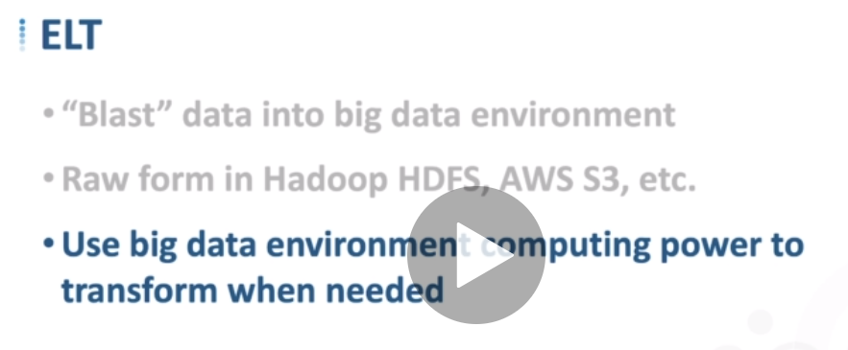

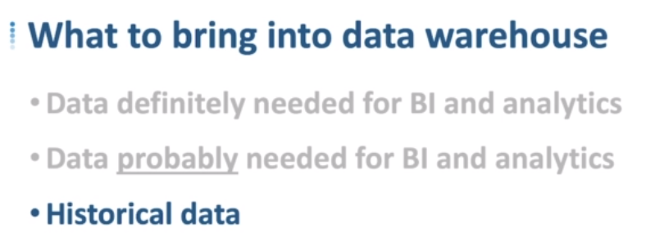

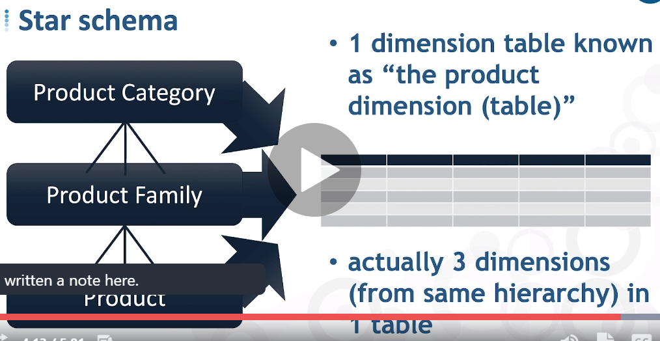

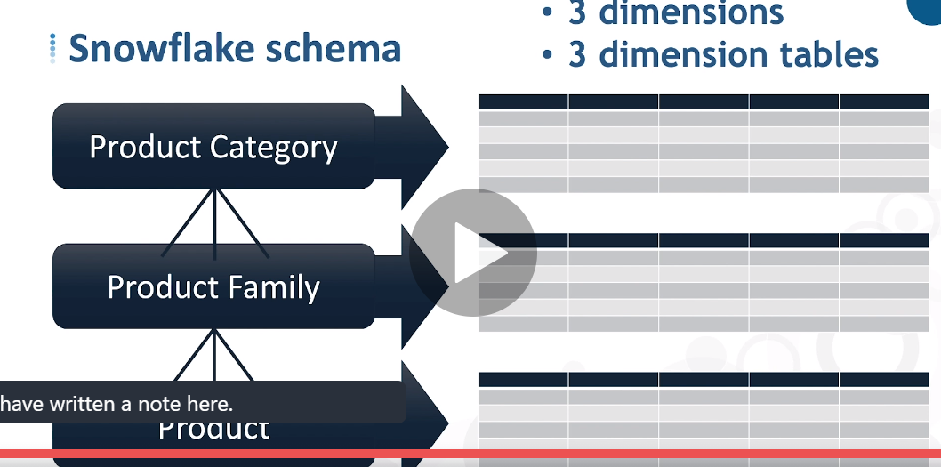

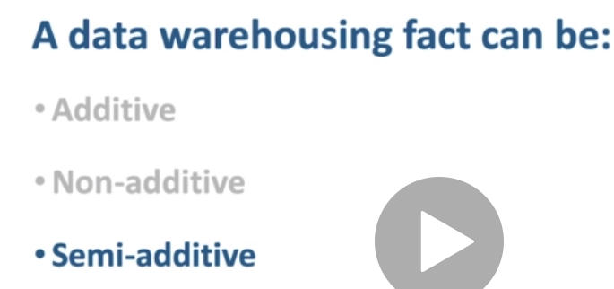

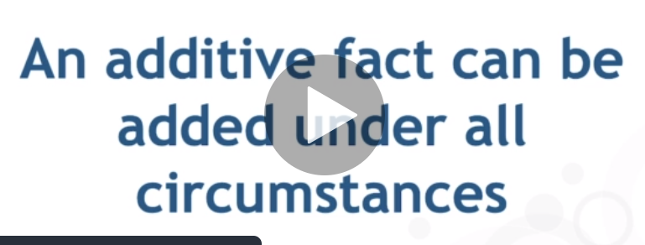

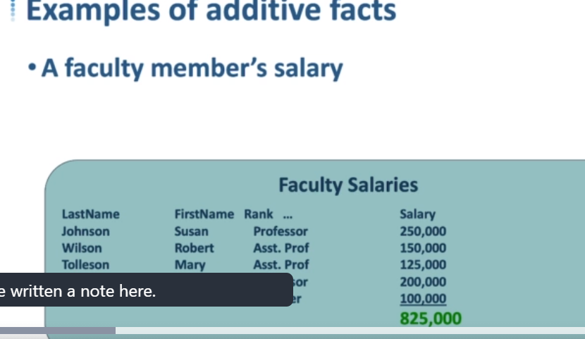

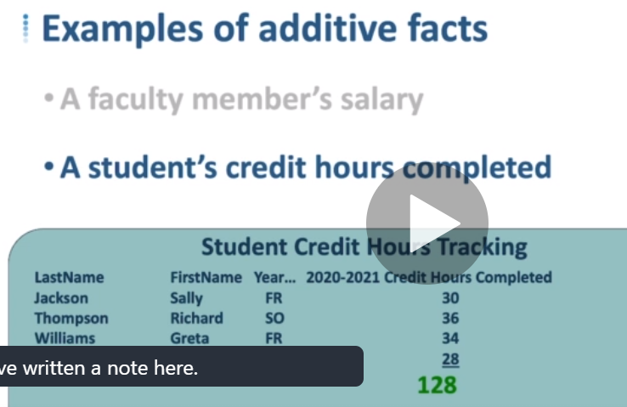

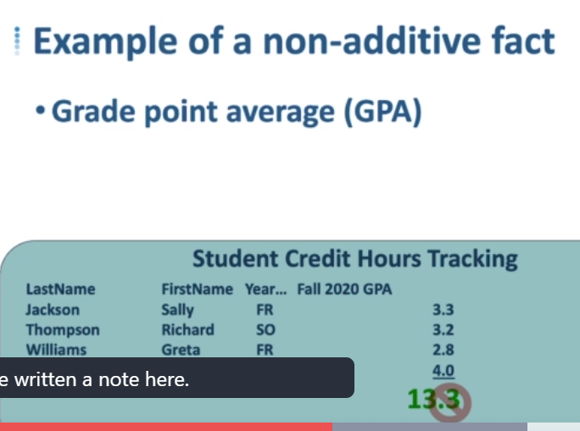

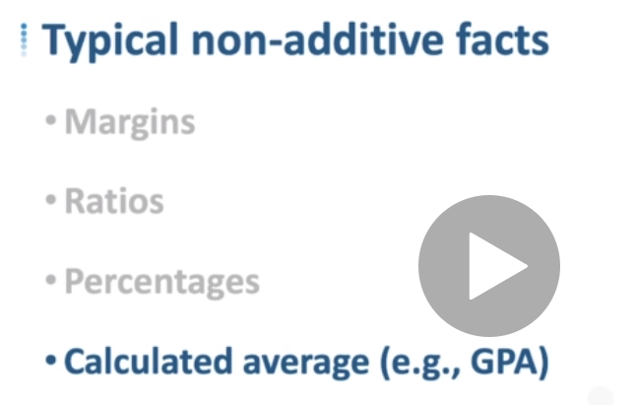

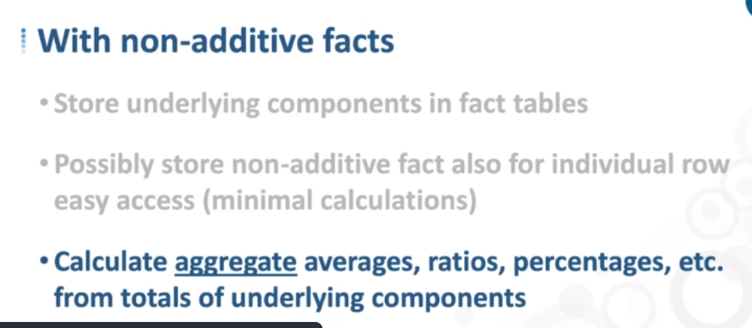

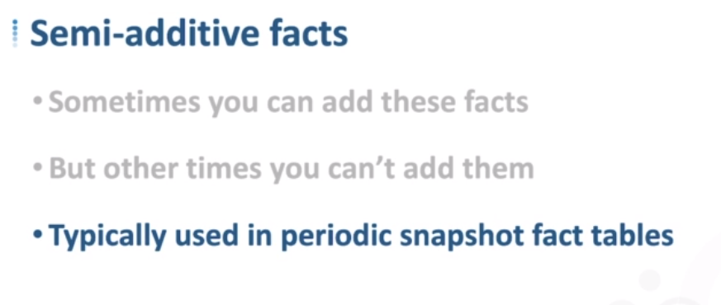

**Additive:**  
  
Additive facts are facts that can be summed up through all of the dimensions in the fact table. A sales fact is a good example for additive fact.  
  
**Semi-Additive:**  
  
Semi-additive facts are facts that can be summed up for some of the dimensions in the fact table, but not the others.  
Eg: Daily balances fact can be summed up through the customers dimension but not through the time dimension.  
  
**Non-Additive:**  
  
Non-additive facts are facts that cannot be summed up for any of the dimensions present in the fact table.  
Eg: Facts which have percentages, ratios calculated.

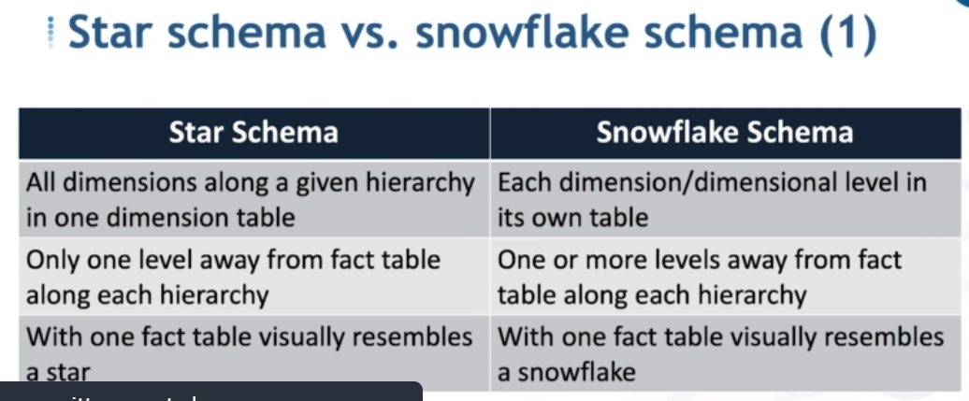

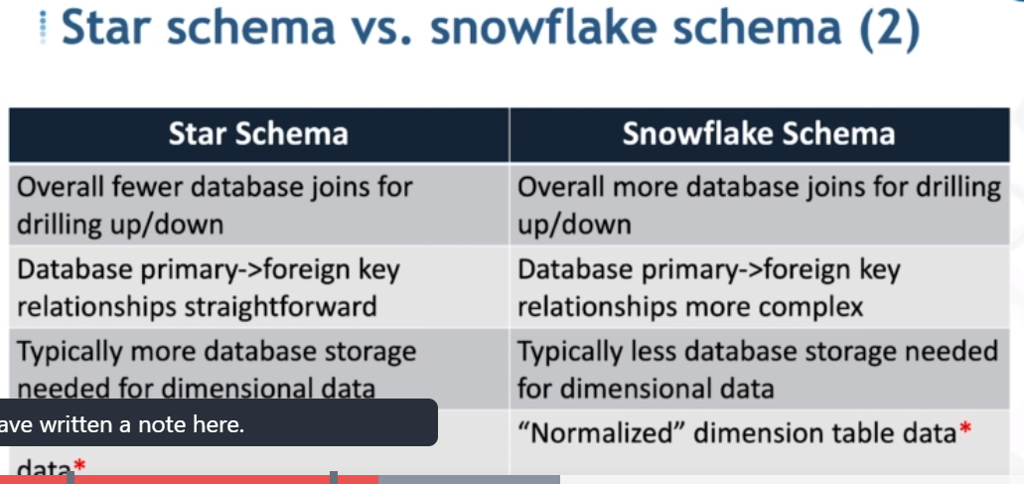

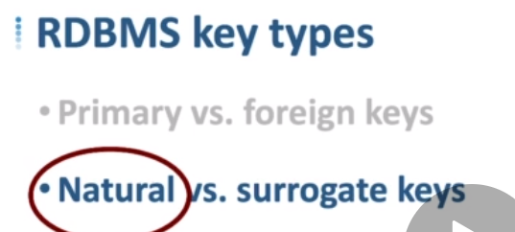

**Natural Keys**

If a key’s attribute is used for identification independently of the database scheme, it is called a Natural Key. In layman’s language, it means keys are natural if people use them, for example, SSN, Invoice ID, Tax ID, Vehicle ID, person unique identifiers, etc. The attributes of a natural key always exist in real world.

*Pros:*

* No additional Index is required.
* It can be used as a search key.

*Cons:*

* While using strings, joins are a bit slower as compared to the int data-type joins, storage is more as well. Since storage is more, less data-values get stored per index page. Also, reading strings is a two step process in some RDBMS: one to get the actual length of the string and second to actually perform the read operation to get the value.
* Locking contentions can arise while using application driven generation mechanism for the key.
* You can’t enter a record until the value is known since the value has some meaning.

**Surrogate Keys**

Surrogate keys have no “business” meaning and their only purpose is to identify a record in the table. They are always generated independently of the current row data. Their generation can be managed by the database system or the server itself.

*Pros:*

* Business Logic is not in the keys.
* Small 4-byte key (the surrogate key will most likely be an integer and SQL Server for example requires only 4 bytes to store it, if a bigint, then 8 bytes).
* Joins are very fast.
* No locking contentions because of unique constraint (this refers to the waits that get developed when two sessions are trying to insert the same unique business key) as the surrogates get generated by the Database and are cached.

*Cons:*

* An additional index is needed.
* They cannot be used as a search key.
* If it is database controlled, for products that support multiple databases, different implementations are needed, example: identity in SS2k, before triggers and sequences in Oracle, identity/sequence in DB2 UDB.
* Always requires a join when browsing the child tables.

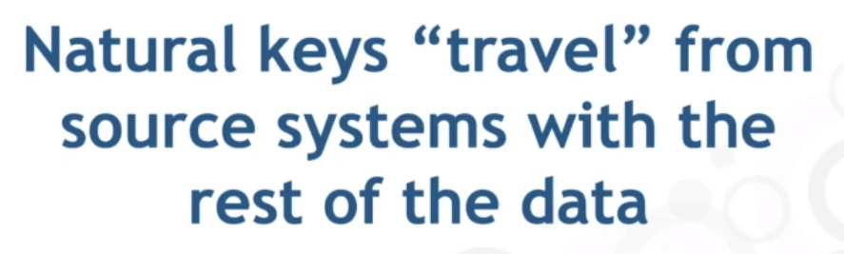

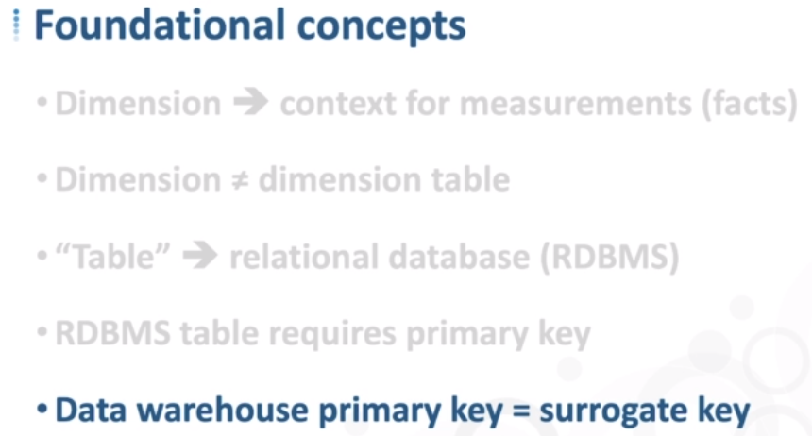

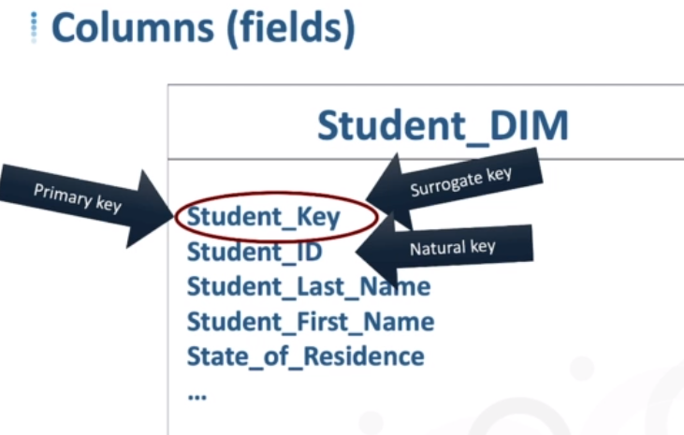

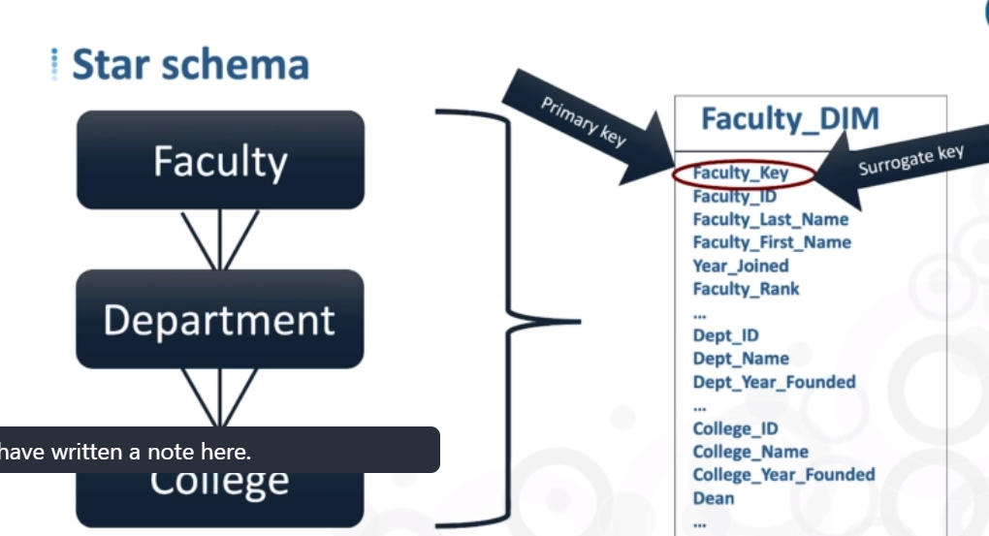

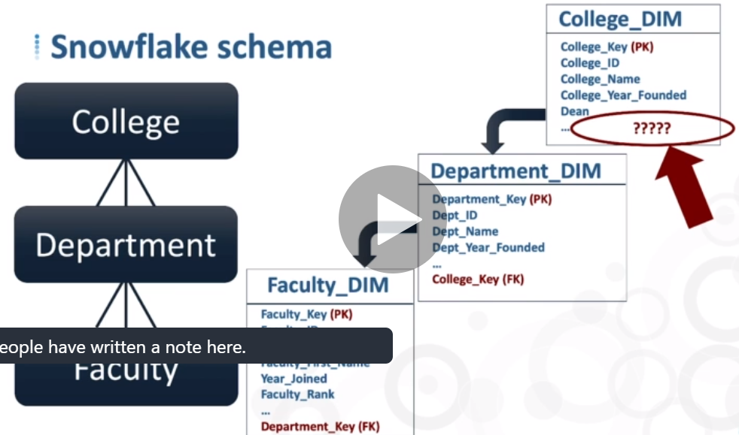

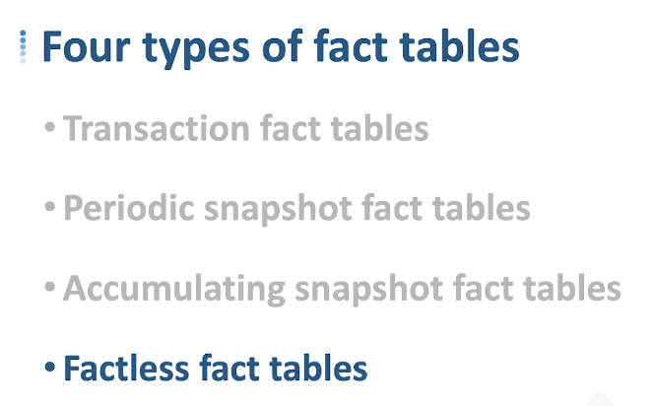

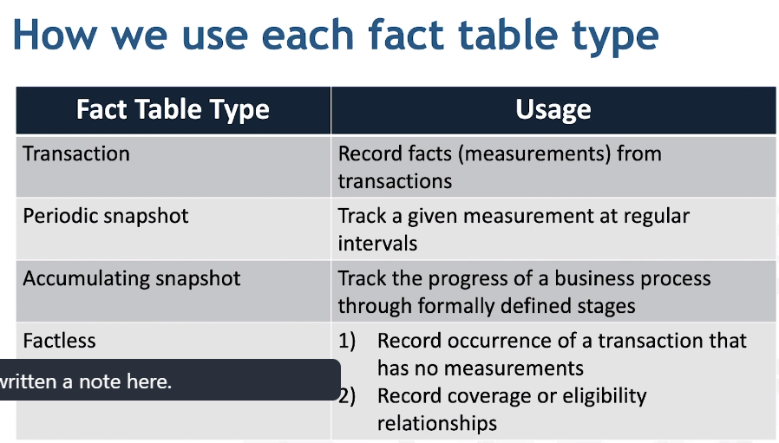

### **1. Transaction Fact Table**

The transaction fact table is a basic approach to operate the businesses. These fact tables represent an event that occurs at the primary point. A line exists in the fact table for the customer or product when the transaction occurs.

Many rows in a fact table connect to a customer or product because they are involved in multiple transactions. Transaction data is often structured quickly in a one-dimensional framework. The lowest-level data is the rawest dimensional data that cannot be done by summarized data.

### **2. Snapshot Fact Table**

The snapshot fact table describes the state of things at a particular time and contains many **semi-additive** and **non-additive** facts.

**Example:** The daily equilibrium fact is expressed by the customer dimension but not by the time dimension.

Periodic snapshots require the performance of the business at regular and estimated time intervals. Unlike a transaction fact table where we load a row for each event, with periodic snapshots, we take a picture of the activity at the end of the day, week, or month, and then another picture at the end of the next period.

**Example:** Performance summary of a salesman during the previous month.

### **3. Accumulated Fact Sheet**

The accumulated fact table is used to show the activity of a process that has a beginning and an end.

For example, we are processing an order. An order remains in the process until it will be processed. As the step towards completing the order is completed, the corresponding row in the fact table is updated.

### **Fact less Facts**

We have also a transaction fact tables which contain no measures. We call it as fact less fact tables. These tables are used to capture the action of the business process. **For example,** a criminal case is a simple fact with no measures but can have a lot of dimensional attributes associated with the fact.

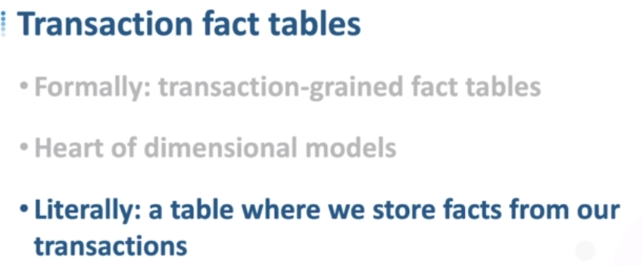

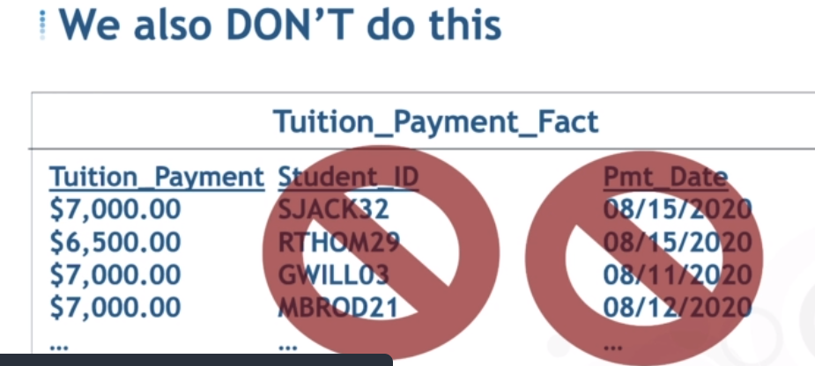

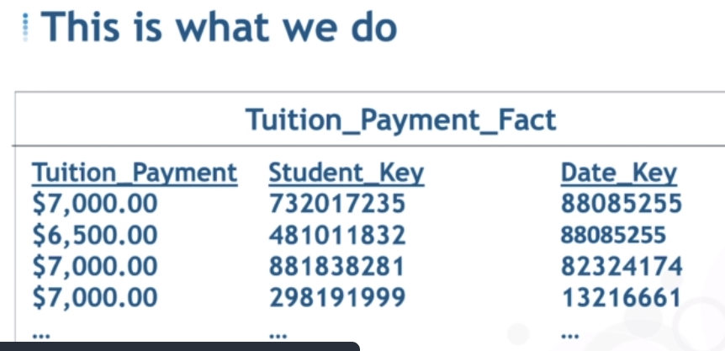

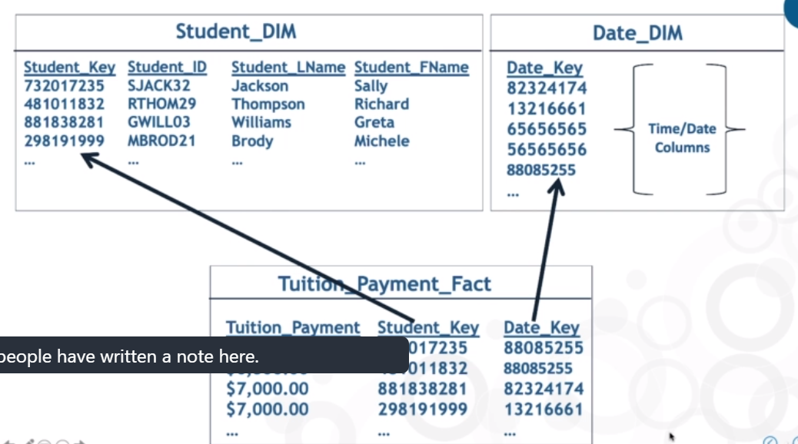

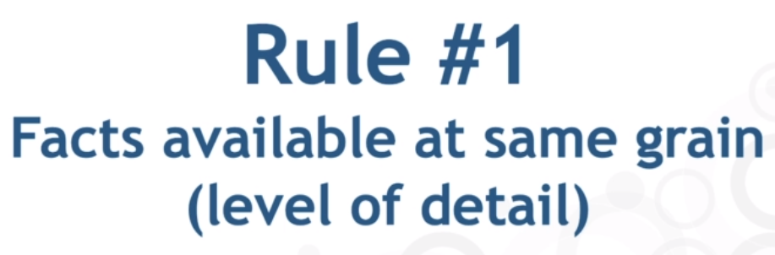

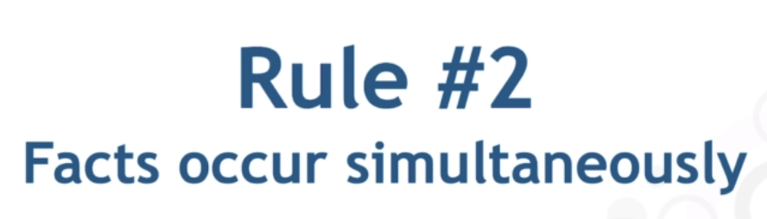s

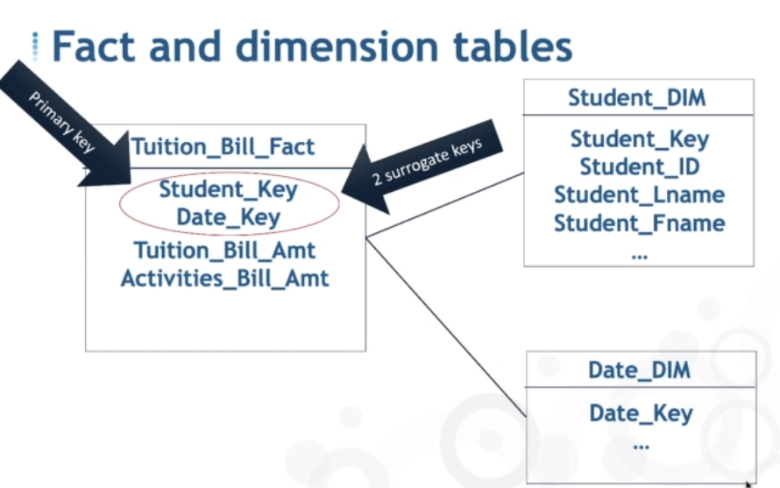

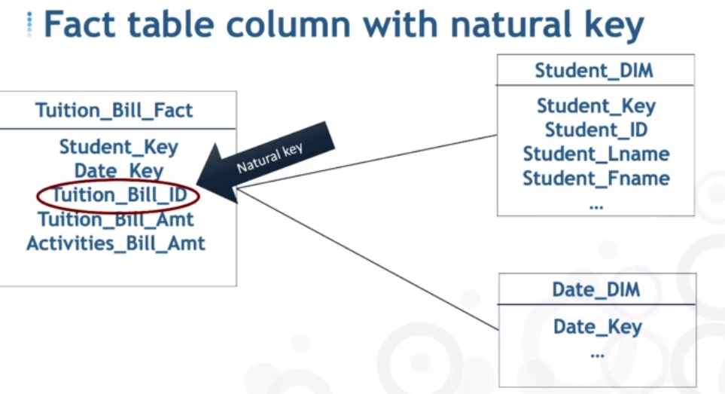

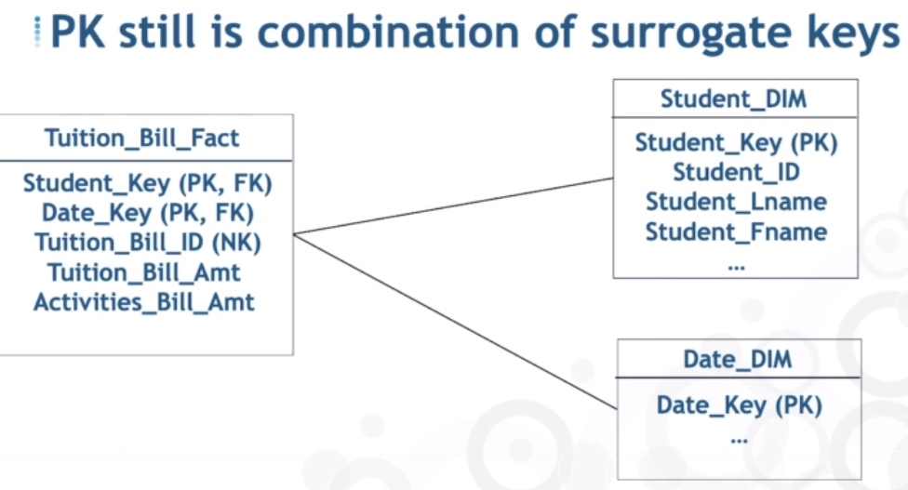

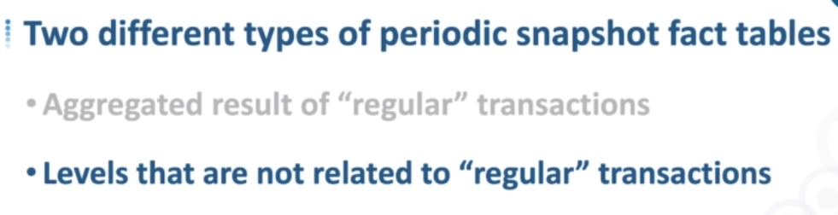

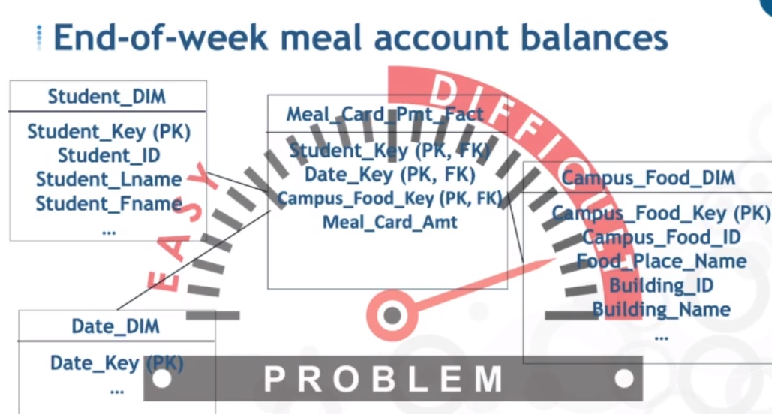

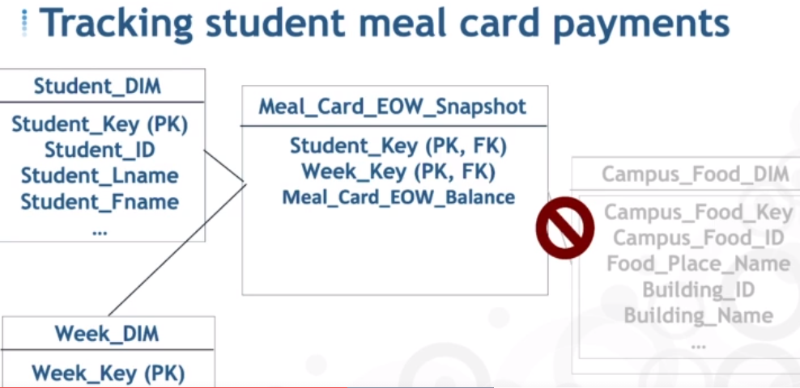

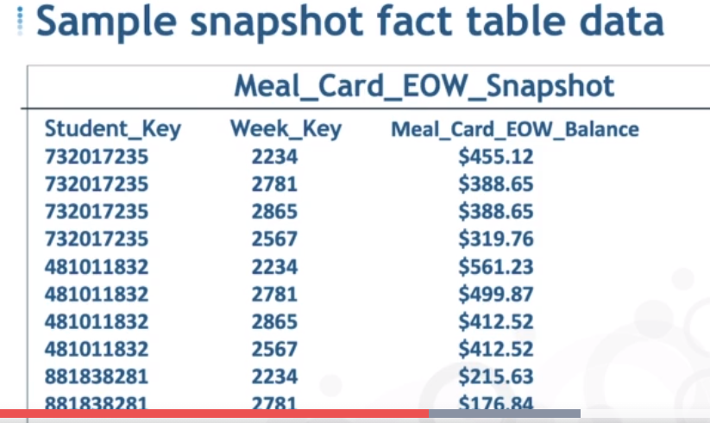

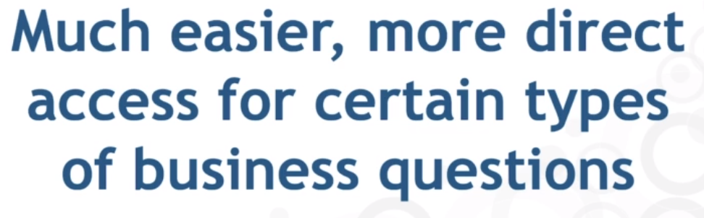

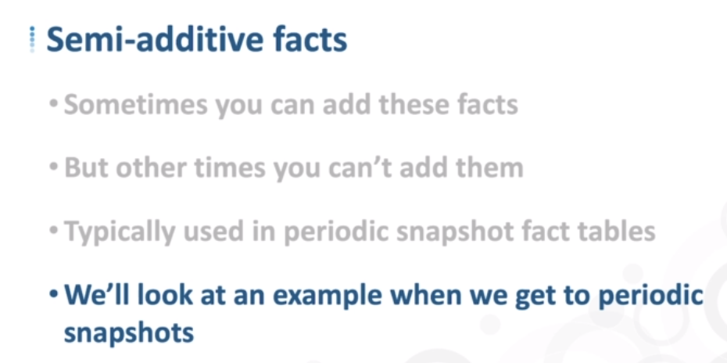

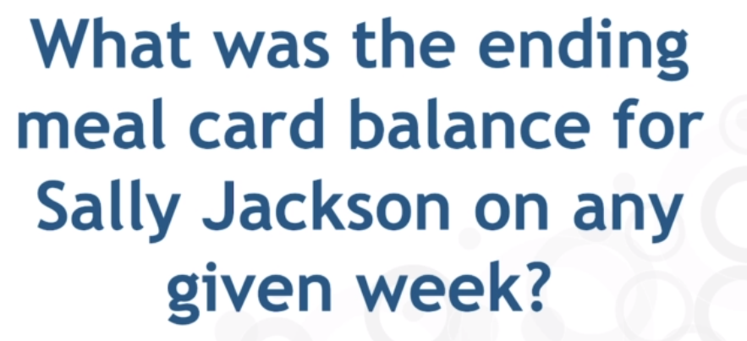

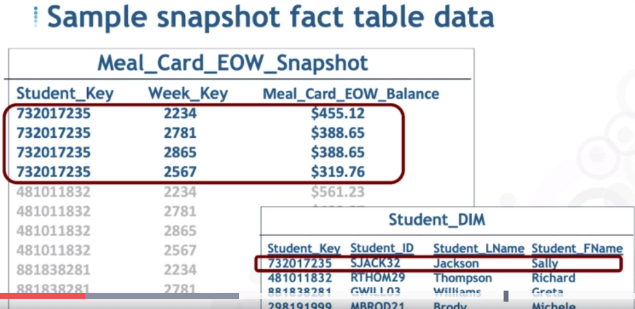

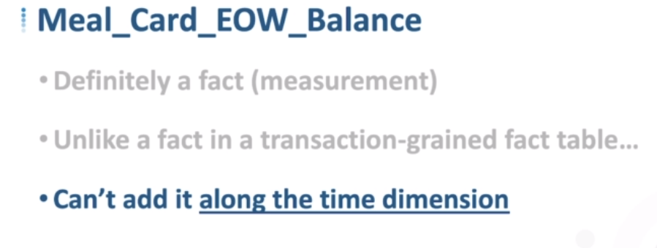

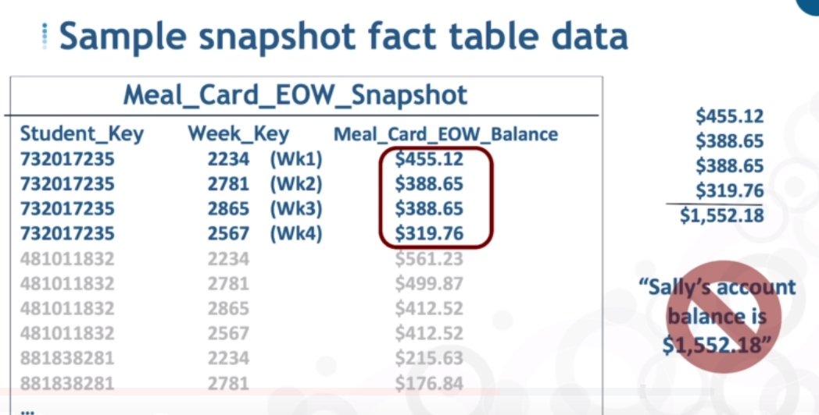

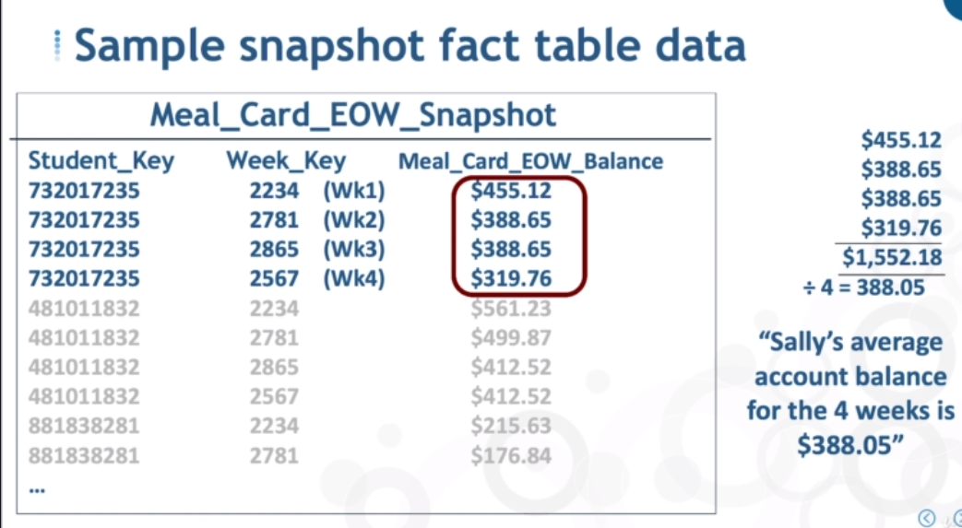

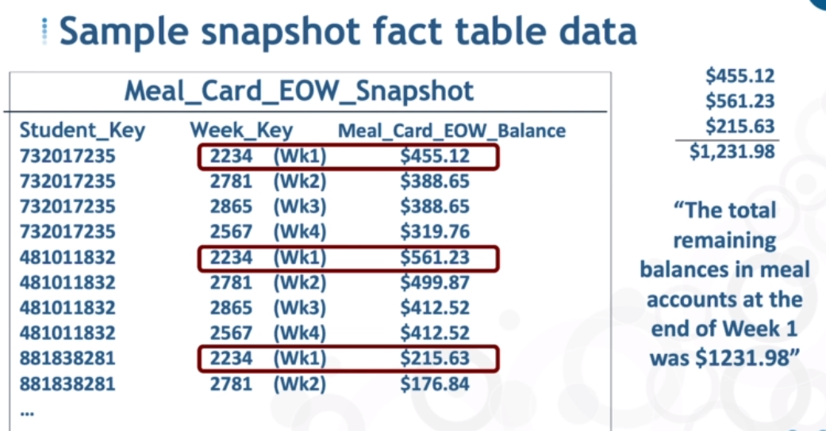

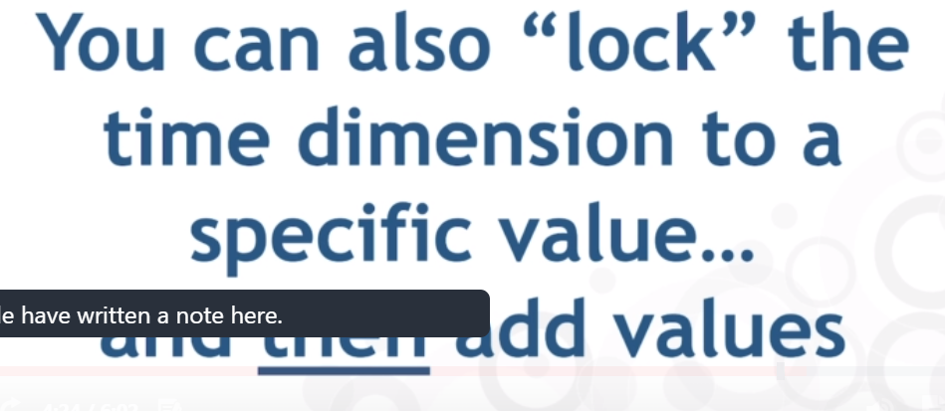

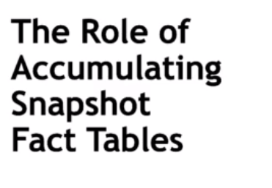

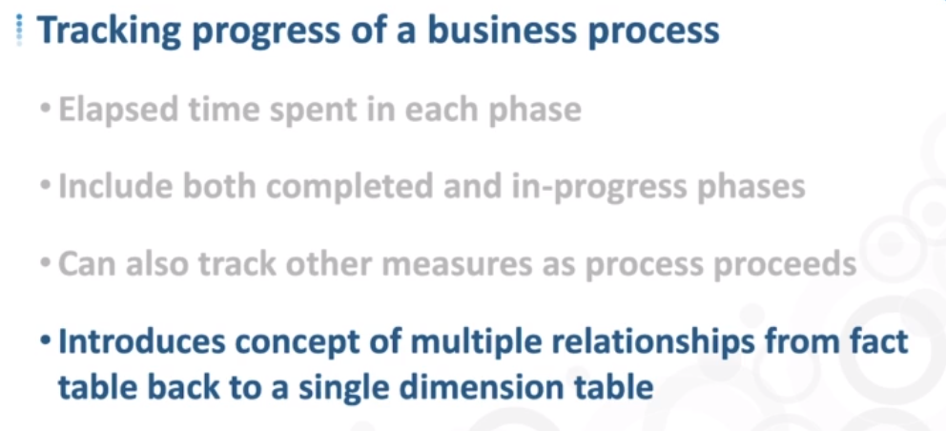

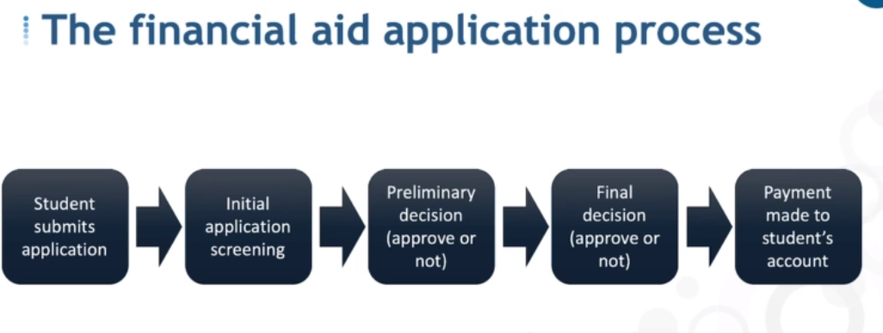

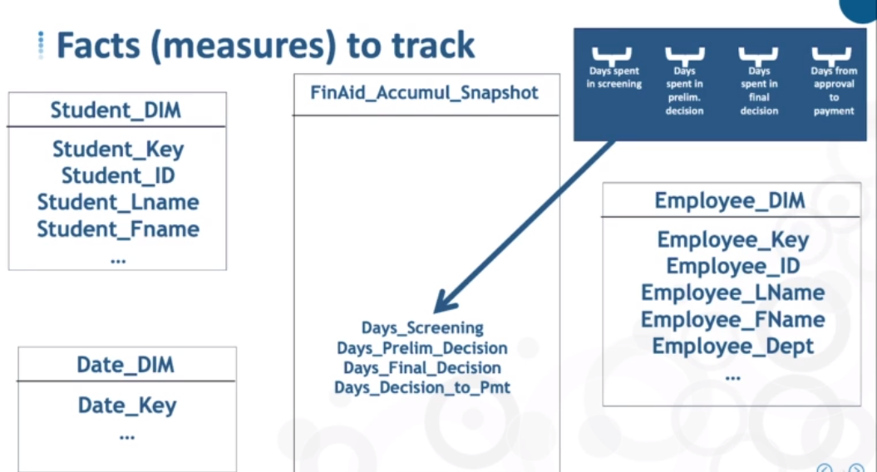

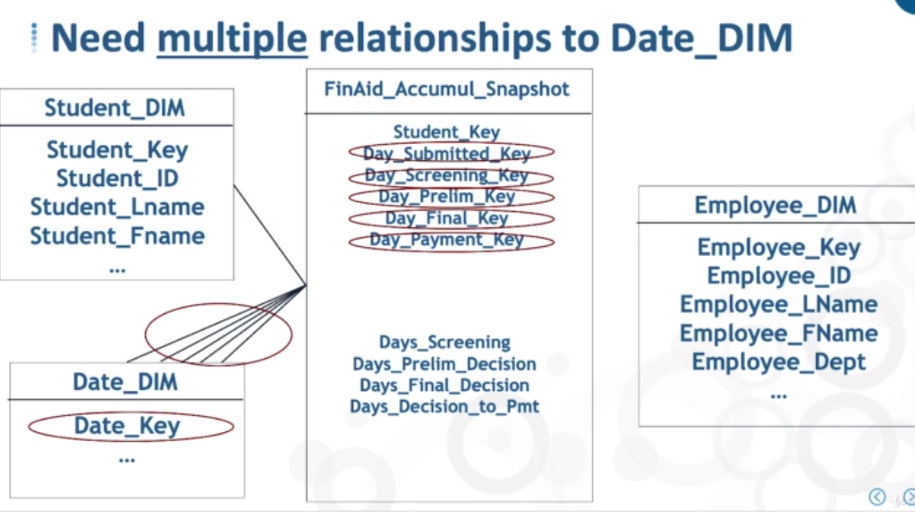

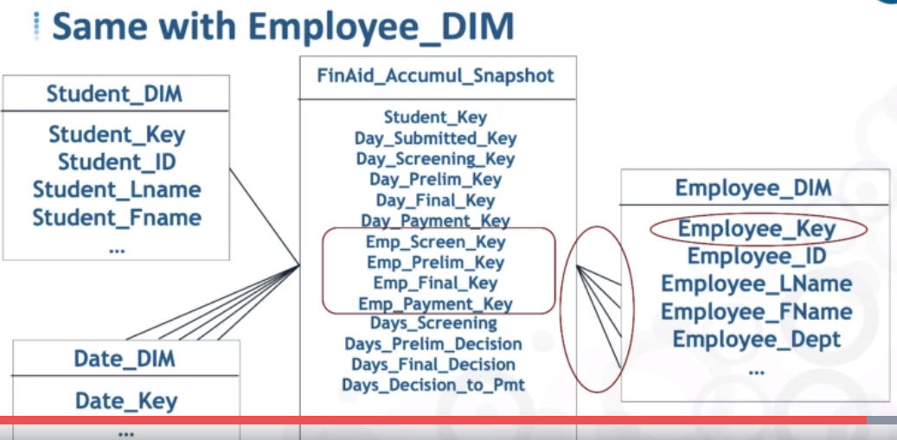

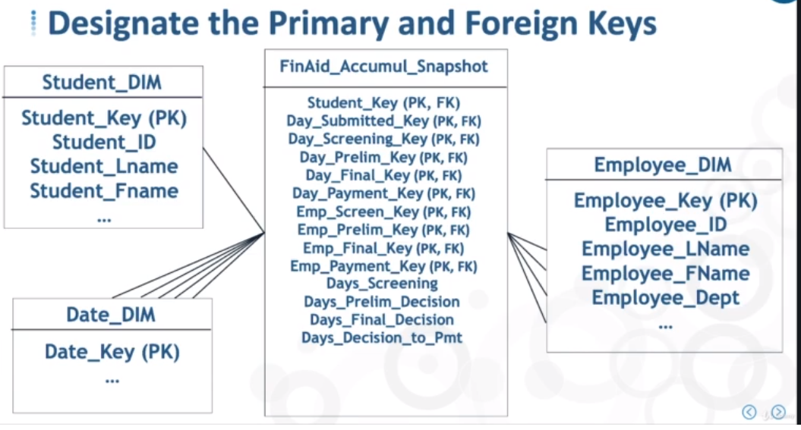

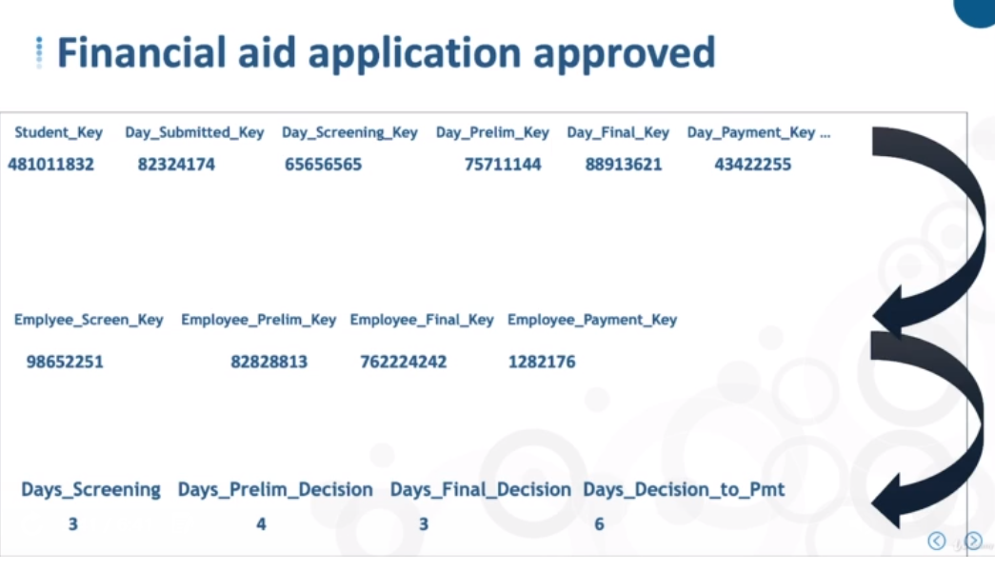

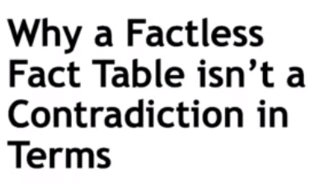

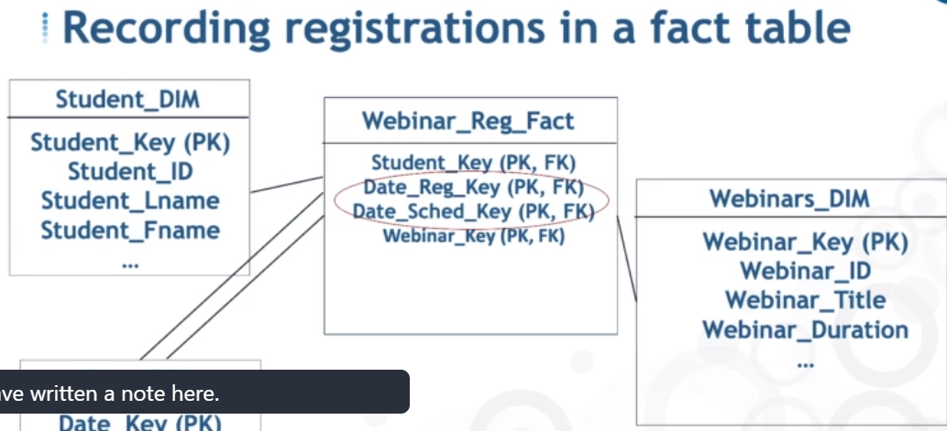

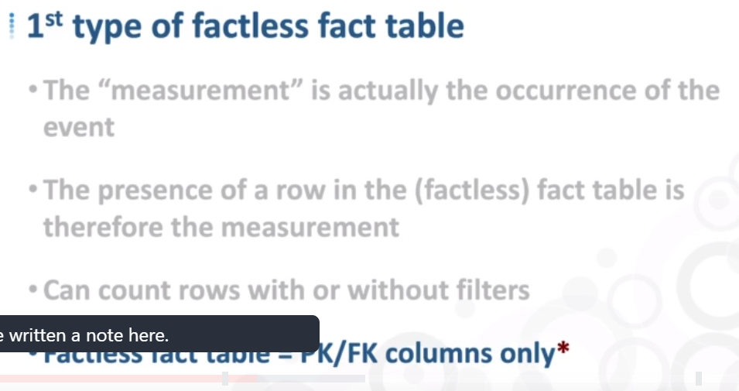

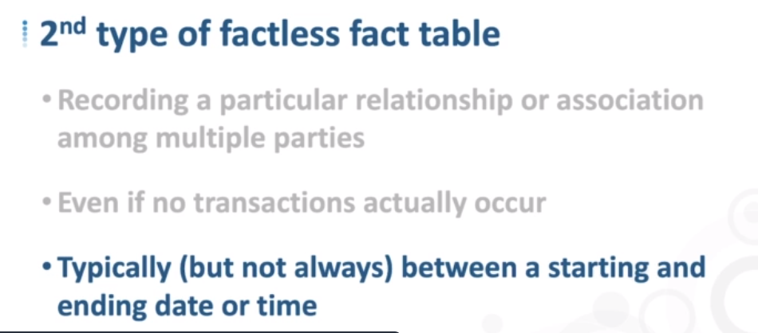

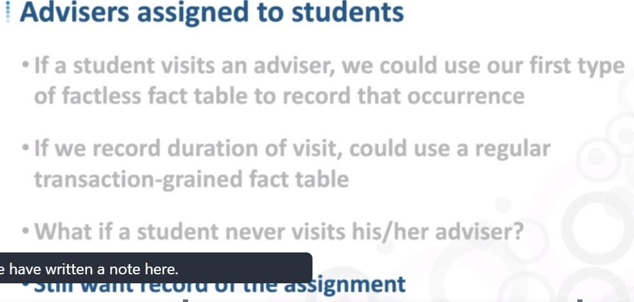

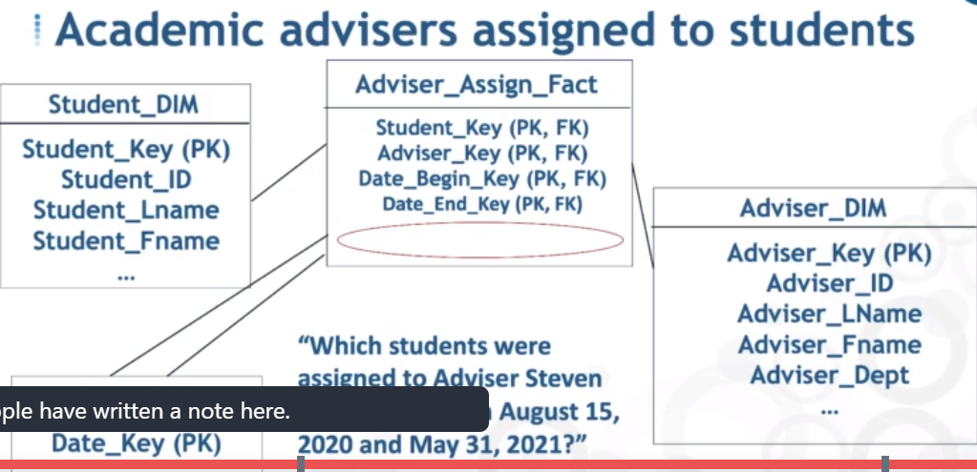

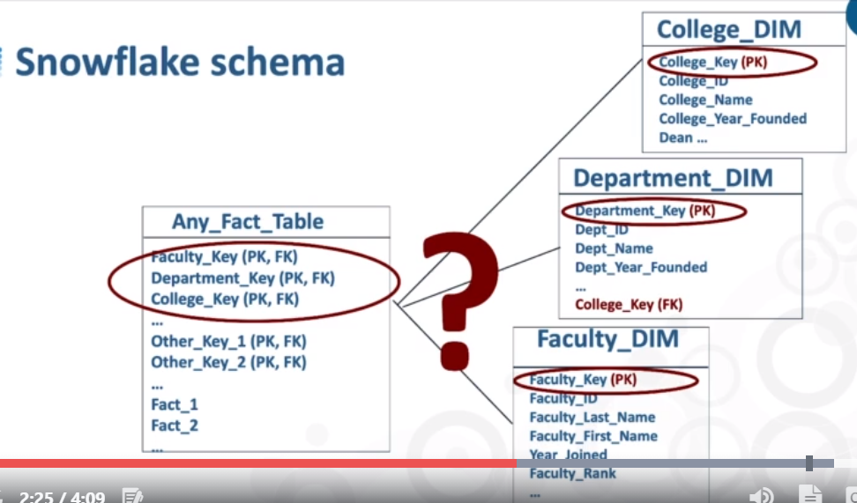

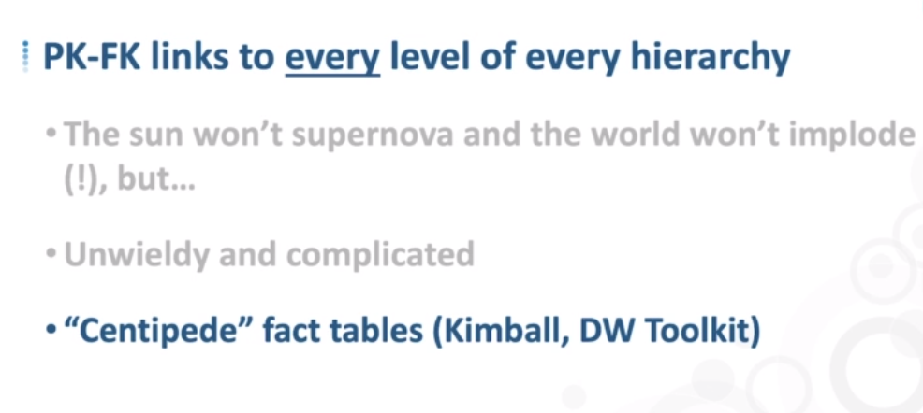

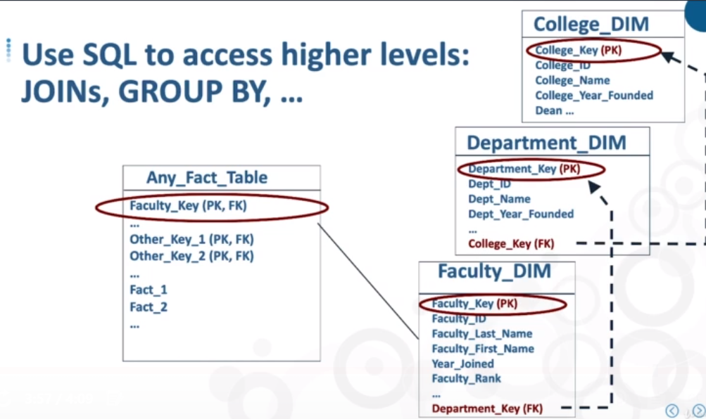

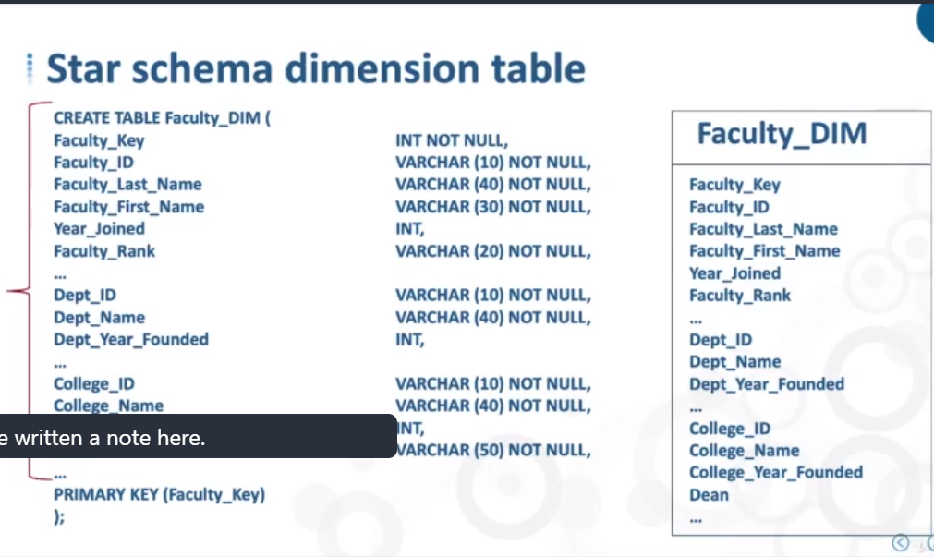

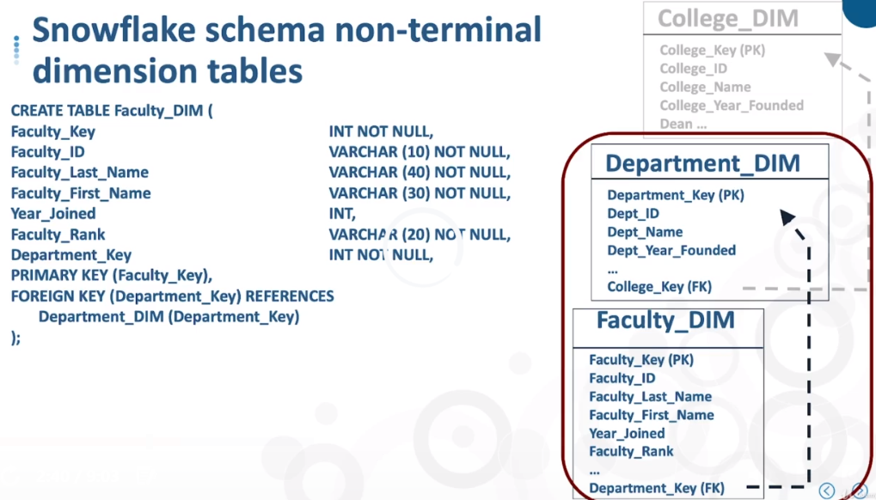

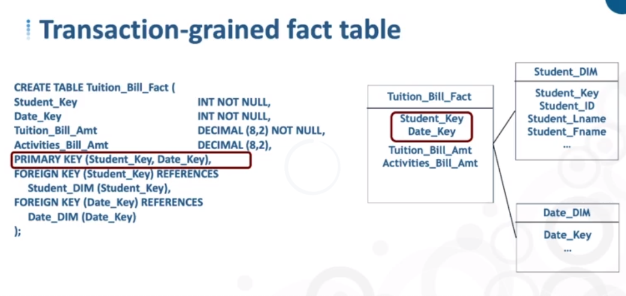

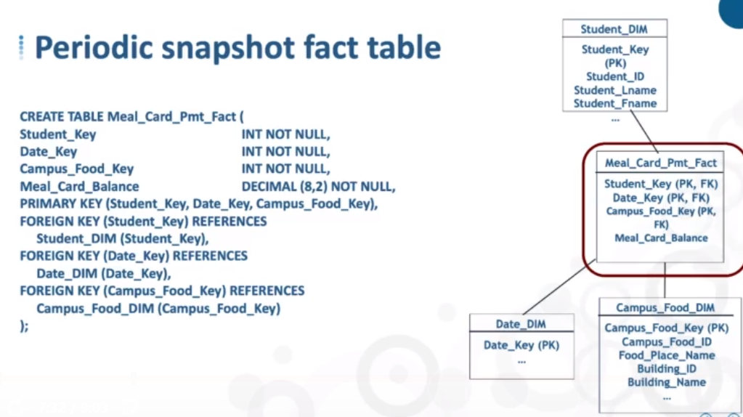

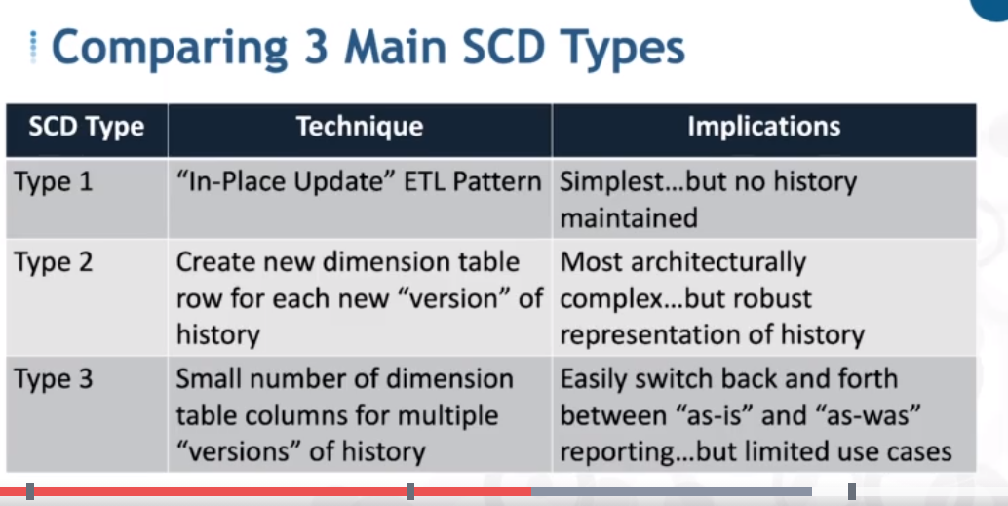

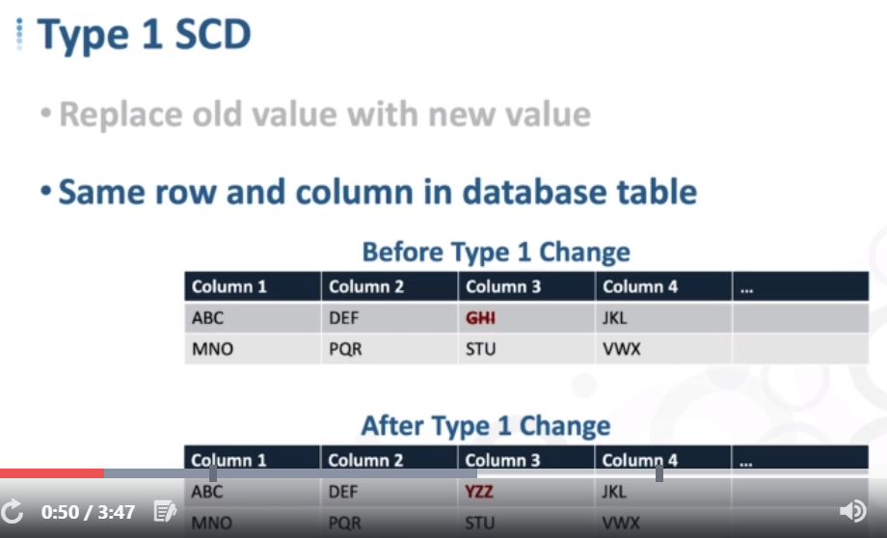

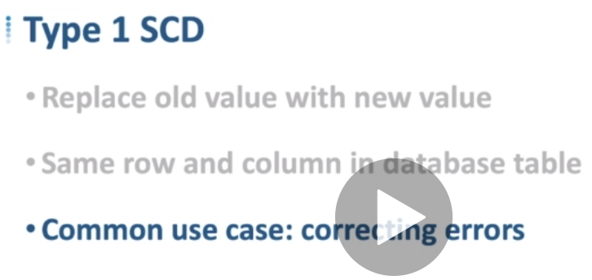

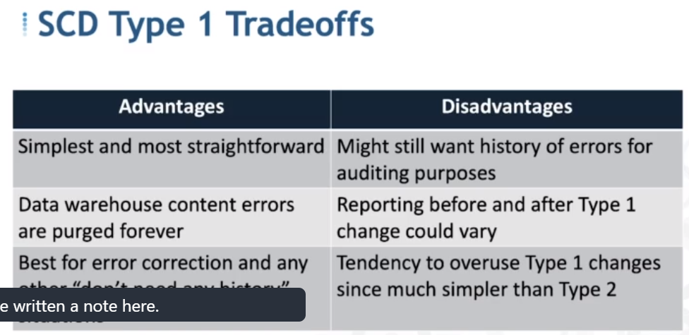

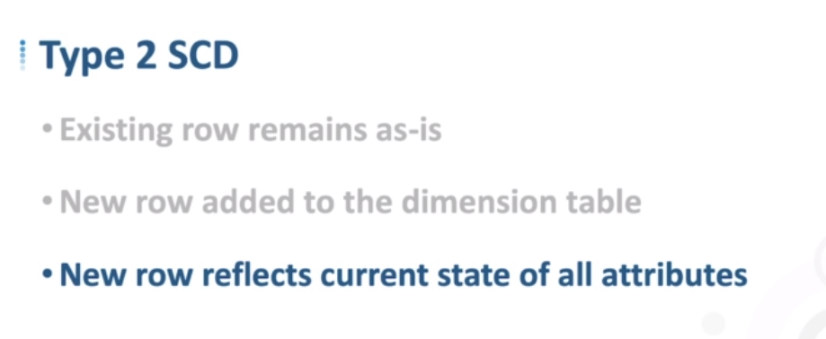

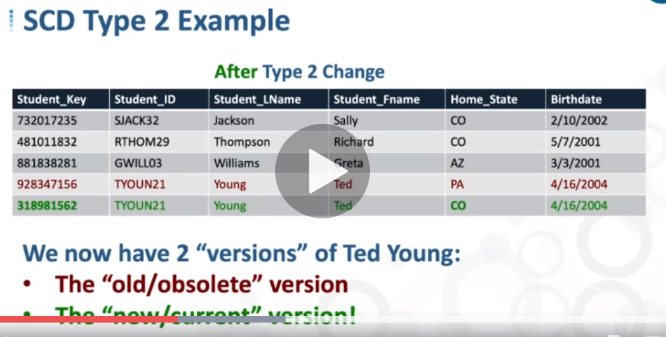

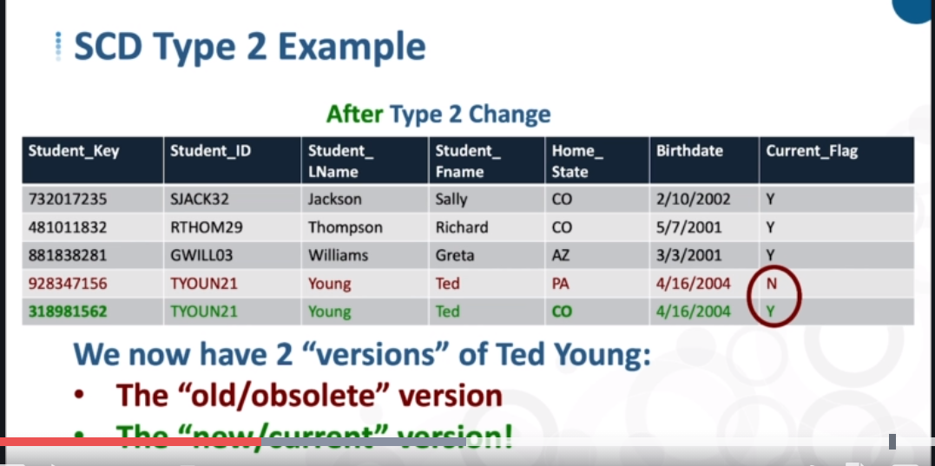

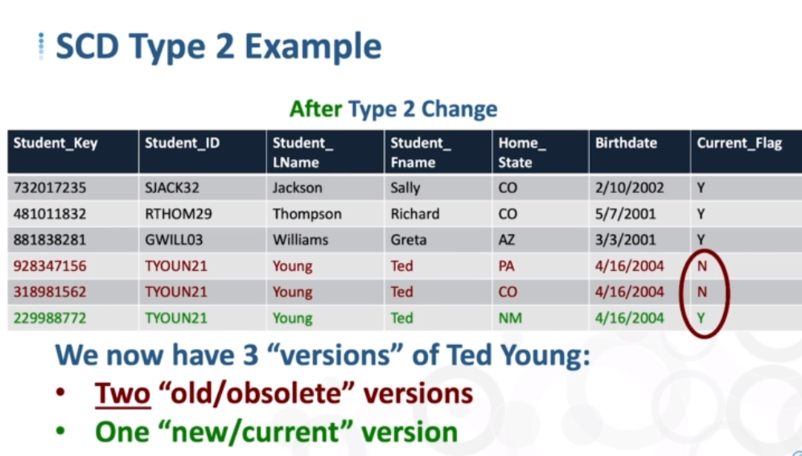

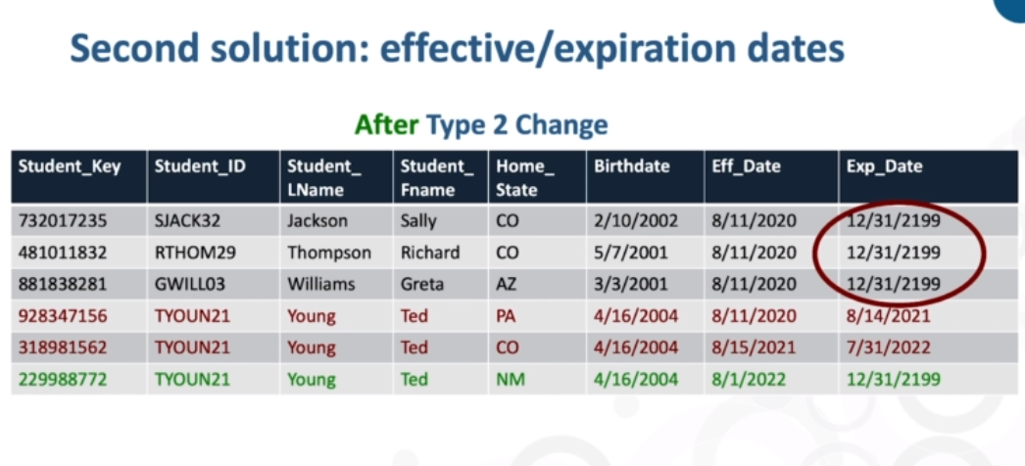

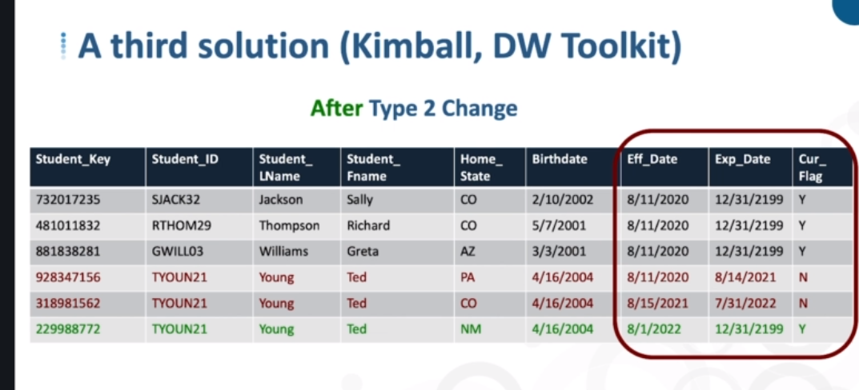

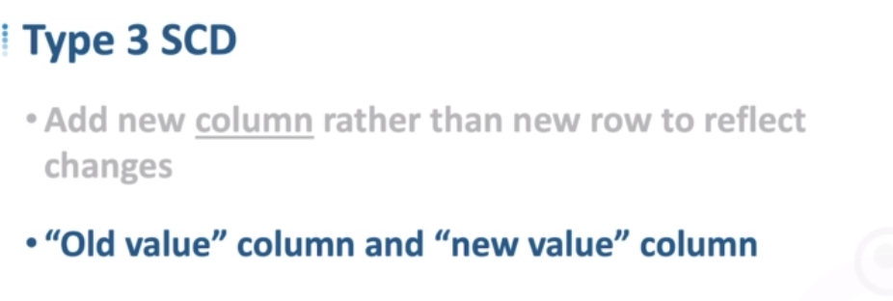

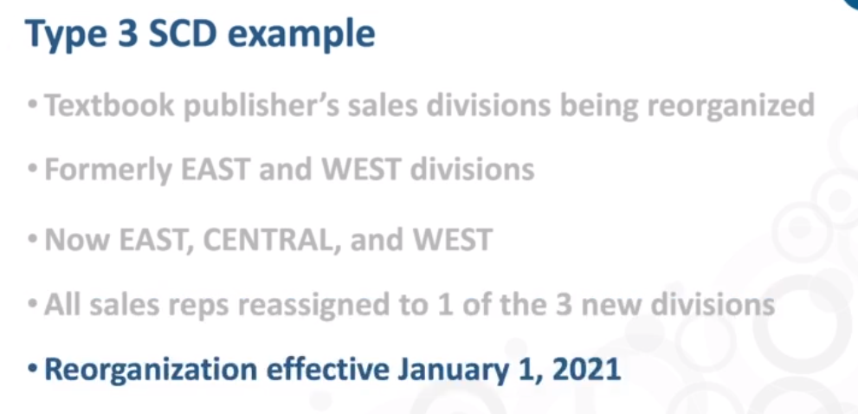

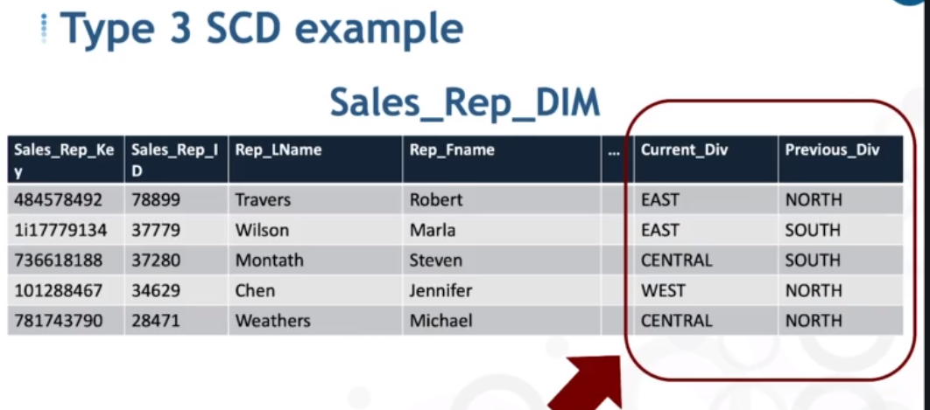

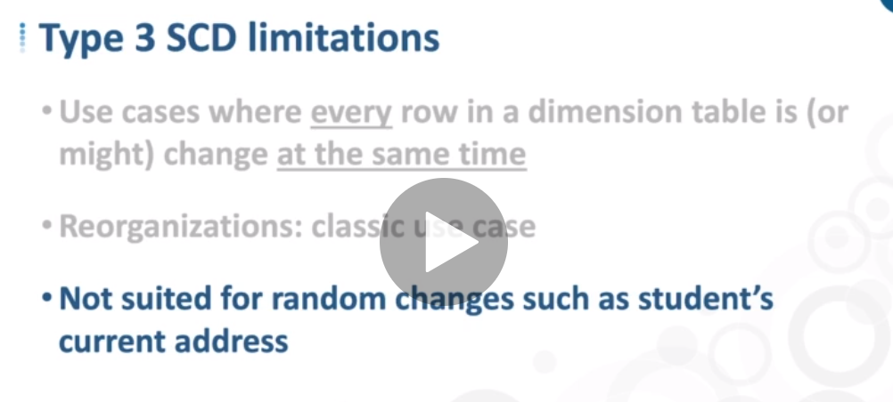

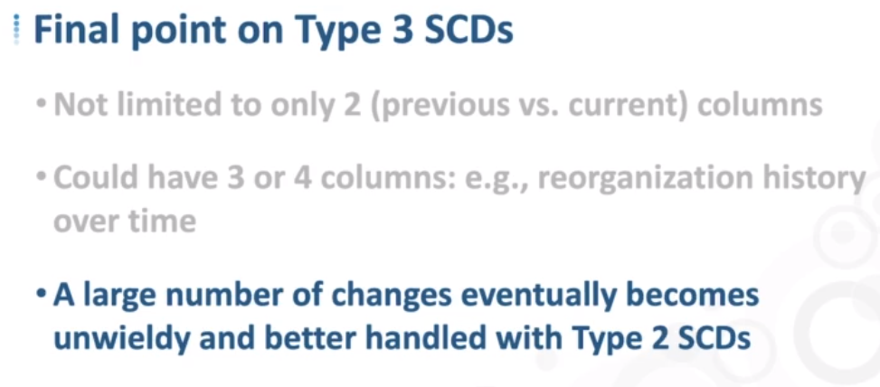

## What is SCD Type 6

Its a hybrid approach, a combination of all three basic SCD techniques, hence its named 1+2+3 = 6. Type 6 is particularly applicable if you want to maintain complete history like Type 2 and would also like to have an easy way to effect on current version like Type 3

Lets see consider Customer Dimension, which is modeled as Type 6. This dimension will have two INCOME GROUP attributes, one to capture current and other to capture the historical changes. Initially the customer is in LOW income group, so both income attributes have the same values.  
  
Below image shows the initial data in Customer Dimension.

[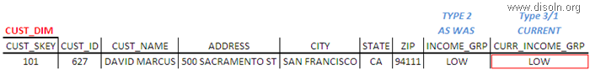](http://lh5.ggpht.com/-LxVhqSw-is4/UWuIcv_ff5I/AAAAAAAAHx4/PJj1JiDsEps/s1600-h/image%25255B58%25255D.png)

When the customer's income group is changed, a new dimension record is added to keep the historical changes for the customer. In the new dimension record current income group will be identical to income group. For all previous instances of customer dimension rows, the current income attribute will be overwritten to reflect the latest value.

[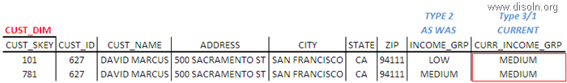](http://lh3.ggpht.com/-DadUsE3pNUA/UWuIdkPJTxI/AAAAAAAAHyI/wpJ7aaA89NU/s1600-h/image%25255B64%25255D.png)

Subsequent changes are also treated the same.

[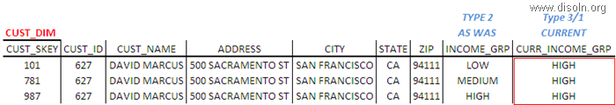](http://lh4.ggpht.com/-o6KV6cvmEqg/UWuIeztlLhI/AAAAAAAAHyY/s0ZQ8NOIXC4/s1600-h/image%25255B70%25255D.png)

With this hybrid approach, we issue a new row to capture the change (type 2) and add a new column to track the current assignment (type 3), where subsequent changes are handled as a type 1 response.

## When to Use SCD Type 6

Data warehousing teams are quite often asked to preserve historical attributes, while also supporting the ability to report historical performance data according to current attribute values. SCD Type 6 is the answer for such requirements.

If you want to see the historical facts based on the current attribute values, we will filter or summarize on the current attributes. If we summarize on the historical attribute, we will see facts as they sum up at a point of time.  
  
Here is our Customer Dimension example, we can use INCOME_GRP column to see the facts values at a point of time and CURR_INCOME_GRP to get the historical fact values based on the current attribute value.